UNITED STATES
SECURITIES AND EXCHANGE COMMISSION
Washington, D.C. 20549

FORM 6-K

REPORT OF FOREIGN PRIVATE ISSUER PURSUANT TO RULE 13a-16 OR
15d-16 UNDER THE SECURITIES EXCHANGE ACT OF 1934

For the month of October 2026
Commission File Number: 001-39911

Patria Investments Limited
(Exact name of registrant as specified in its charter)

60 Nexus Way, 4th floor,
Camana Bay, PO Box 757, KY1-9006
Grand Cayman, Cayman Islands
+1 345 640 4900
(Address of principal executive office)

Indicate by check mark whether the registrant files or will file annual reports under cover of Form 20-F or Form 40-F:

Form 20-F | X |  | Form 40-F

TABLE OF CONTENTS

Exhibit No. | Description
99.1 | Notice of 2026 Annual General Meeting of Shareholders
99.2 | Proxy Statement
99.3 | Form of Proxy Card

SIGNATURE

Pursuant to the requirements of the Securities Exchange Act of 1934, the registrant has duly caused this report to be signed on its behalf by the undersigned, thereunto duly authorized.

 |  |  | Patria Investments Limited
 |  |  | By: | /s/ Raphael Denadai
 |  |  |  | Name: | Raphael Denadai
 |  |  |  | Title: | Chief Financial Officer

Date: October 5, 2026

Exhibit 99.1

Patria Investments Limited

(the “Company”)

NOTICE OF ANNUAL GENERAL MEETING OF THE COMPANY

NOTICE IS HEREBY GIVEN that an Annual General Meeting of the Company (the “AGM”) will be held virtually and at the offices of Patria Investments Limited located at 60 Nexus Way, Camana Bay, 4th Floor, KY1-9006, Grand Cayman, Cayman Islands on October 26, 2026 at 3:00 p.m. (Eastern Time).

The AGM will be held in accordance with Cayman Islands law and the amended and restated memorandum and articles of association of the Company and in a virtual form. You will be able to attend the AGM online by visiting https://meetnow.global/MG7JSS9. You also will be able to vote your shares online by attending the AGM by webcast. To participate in the AGM, you will need to review the information included on proxy or in the instructions that accompanied your proxy materials. The details of how to participate virtually at the AGM are also set out in the accompanying proxy card.

The AGM will be held for the purpose of considering and, if thought fit, passing and approving the following resolutions:

 | 1 | RESOLVED, as an ordinary resolution, that the Company’s financial statements and the auditor's report for the fiscal year ended 31 December 2025, which have been made available to the Shareholders for the purpose of the AGM be approved and ratified; and

 | 2 | RESOLVED, as an ordinary resolution, that Alfonso Duval be appointed as a member of the Board of Directors of the Company, to serve on the Board until the earlier of his vacating office or removal from office as a director in accordance with the Amended and Restated Memorandum and Articles of Association of the Company.

 | 3 | RESOLVED, as an ordinary resolution, that Ana Russo be appointed as a member of the Board of Directors of the Company, to serve on the Board until the earlier of her vacating office or removal from office as a director in accordance with the Amended and Restated Memorandum and Articles of Association of the Company.

 | 4 | RESOLVED, as an ordinary resolution, that Andre Sales be appointed as a member of the Board of Directors of the Company, to serve on the Board until the earlier of his vacating office or removal from office as a director in accordance with the Amended and Restated Memorandum and Articles of Association of the Company.

On June 12, 2026 and September 3, 2026, Alfonso Duval and Ana Russo, respectively, were appointed by the board as interim board members, with their term expiring at the commencement of the AGM. Ana Russo’s, Alfonso Duval’s and Andre Sales’ profiles are included in the Schedule to this notice.

The Board of Directors of the Company (the “Board”) has fixed the close of business (Eastern Time) on September 22, 2026 as the record date (the “Record Date”) for determining the shareholders of the Company entitled to receive notice of the AGM or any adjournment thereof. The holders of record of the Class A common shares and the Class B common shares of the Company as of the close of business (Eastern Time) on the Record Date are entitled to receive notice of and attend the AGM and any adjournment thereof. The Board recommends that shareholders of the Company vote “FOR” the resolutions at the AGM. Your vote is very important to the Company.

Please refer to the proxy card which is attached to this notice. The proxy statement and the proxy card are also available for viewing on the shareholders section of our website at https://ir.patria.com/financials-filings/sec-filings and on the SEC’s website at https://www.sec.gov.

Your vote is important. If you do not plan to attend the AGM either in person or virtually then you are urged to complete, sign, date and return the accompanying proxy card to us, in accordance with the instructions set out therein, as promptly as possible and in any case by no later than 11:59 p.m., Eastern time, on October 25, 2026 to ensure your representation at the AGM.

The Company’s Annual Report on Form 20-F for the fiscal year ended December 31, 2025 was filed with the U.S. Securities and Exchange Commission on April 30, 2026 (the “Form 20-F”). Shareholders may obtain a copy of the Form 20-F, free of charge, from the Company’s website at https://ir.patria.com/financials-filings/sec-filings and on the SEC’s website at https://www.sec.gov or by contacting the Company’s Investor Relations Department by email at PatriaShareholderRelations@patria.com. In addition to the other information included in the Form 20-F, you will find in the Form 20-F biographies for the incumbent members of the Board.

By Order of the Board of Directors

/s/ Alexandre Teixeira de Assumpção Saigh
Name: | Alexandre Teixeira de Assumpção Saigh
Title: | Director
Dated: | October 5, 2026

Registered Office:
c/o Maples Corporate Services Limited
PO Box 309, Ugland House
Grand Cayman
KY1-1104
Cayman Islands

2

- NOTES

IF YOU HAVE EXECUTED A STANDING PROXY, YOUR STANDING PROXY WILL BE VOTED AS INDICATED IN NOTE 2 BELOW, UNLESS YOU ATTEND THE AGM IN PERSON OR SEND IN A SPECIFIC PROXY.

 | 1 | A proxy need not be a shareholder of the Company. A shareholder entitled to attend and vote at the AGM is entitled to appoint one or more proxies to attend and vote in his/her stead.

 | 2 | Any standing proxy previously deposited by a shareholder with the Company will be voted in favor of the resolutions to be proposed at the AGM unless revoked prior to the AGM or the shareholder attends the AGM in person or executes a specific proxy.

 | 3 | If two or more persons are jointly registered as holders of a share, the vote of the senior person who tenders a vote, whether in person or by proxy, shall be accepted to the exclusion of the votes of other joint holders. For this purpose, seniority shall be determined by the order in which the names stand on the Company’s register of shareholders in respect of the relevant shares.

 | 4 | Each Class A Common Share shall entitle the holder to one (1) vote on all matters subject to a vote at general meetings of the Company, and each Class B Common Share shall entitle the holder to ten (10) votes on all matters subject to a vote at general meetings of the Company.

 | 5 | A shareholder holding more than one share entitled to attend and vote at the AGM need not cast the votes in respect of such shares in the same way on any resolution and therefore may vote a share or some or all such shares either for or against a resolution and/or abstain from voting a share or some or all of the shares and, subject to the terms of the instrument appointing any proxy, a proxy appointed under one or more instruments may vote a share or some or all of the shares in respect of which he is appointed either for or against a resolution and/or abstain from voting.

 | 6 | No business shall be transacted at the AGM unless a quorum is present. As set out in the articles of association of the Company, one or more shareholders holding not less than one-third in aggregate of the voting power of all shares in issue and entitled to vote, present in person or by proxy or, if a corporation or other non-natural person, by its duly authorized representative, constitutes a quorum of the shareholders. No person shall be entitled to vote at the AGM unless he is registered as a shareholder of the Company on the record date for the AGM nor unless all calls or other sums presently payable by him in respect of such shares have been paid.

3

Schedule

Alfonso Duval is currently a Partner and our Head of Clients for the Andean Region. Alfonso joined Patria in 2021 following the combination of Patria and Moneda Asset Management. His tenure at Moneda began in May 2006 and became a partner in 2010. Prior to joining Moneda, Alfonso served in investment banking roles in Chile. Mr. Duval holds a degree in Business Administration from Pontificia Universidad Católica de Chile.

Ana Russo previously served as our Chief Financial Officer from October 2022 through to April 2026. Before taking over as CFO of Patria, Ms. Russo was the department head and CFO for Philip Morris International in Central America & the Caribbean from 2004 to 2007, for the Brazilian operations from 2008 to 2012 (and earlier in her career as CFO for Remy Cointreau Brazil). Ms. Russo also served as CFO of Latin America & Canada for Philip Morris International from 2012 to 2014 and as Chief Auditor reporting to the Audit Committee from 2015 to 2018. She has also developed a deep connection with business process, acting as a Business Partner to division leaders and General Managers, as well as managing a full P&L as CEO of Central America & Caribbean from 2018 to 2022. Ms. Russo holds a bachelor’s and post-graduate’s degrees in business administration from FGV, and a Leadership Program certification from the International Institute for Management Development.

Andre Sales is a Managing Partner & Chief Executive Officer and Chief Investment Officer of our Infrastructure division since August 2006. Mr. Sales is primarily responsible for leading our Infrastructure strategies, conducting infrastructure investment in Latin America. Before taking over as CEO and CIO of our Infrastructure strategies, Mr. Sales worked on numerous investments of Patria Infrastructure Funds I, II and III. Mr. Sales also served as a Director at our M&A Advisory division, and co-CEO of ERSA (our Infrastructure Fund I), a company that later became CPFL Renewables. Prior to joining Patria, Mr. Sales was a Senior Manager in the energy business of Vale, and a Senior Associate in the Infrastructure department of the BNDES - Brazilian National Development Bank. Mr. Sales was a co-founder of an internet community and market place sold to Bradesco in 2000. Mr. Sales also worked for four years at J.P. Morgan in São Paulo and New York in the M&A and Corporate Finance division. Mr. Sales holds a bachelor’s degree in Production Engineering from Escola Politécnica da USP.

4

Exhibit 99.2

Patria Investments Limited
c/o Maples Corporate Services Limited
PO Box 309, Ugland House
Grand Cayman
KY1-1104
Cayman Islands

PROXY STATEMENT

General

The board of directors of Patria Investments Limited (the “Company” “us” or “we”) is soliciting proxies for the Annual General Meeting of shareholders (the “AGM”) of the Company to be held on October 26, 2026 at 3:00 p.m. (Eastern Time). The AGM will be held virtually and at the offices of Patria Investments Limited located at 60 Nexus Way, Camana Bay, 4th Floor, KY1-9006, Grand Cayman, Cayman Islands.

The AGM will be held in accordance with Cayman Islands law and the amended and restated memorandum and articles of association of the Company and in a virtual form. You will be able to attend the AGM online by visiting https://meetnow.global/MG7JSS9. You also will be able to vote your shares online by attending the AGM by webcast. To participate in the AGM, you will need to review the information included on proxy or in the instructions that accompanied your proxy materials. The details of how to participate virtually at the AGM are also set out in the accompanying proxy card.

On or about October 5, 2026, we first mailed to our shareholders the proxy materials, including the proxy statement, the notice to shareholders of our AGM and the proxy card, along with instructions on how to vote using the proxy card provided therewith. This proxy statement can also be accessed, free of charge, on the shareholders section of Patria’s website at https://ir.patria.com/financials-filings/sec-filings and on the SEC’s website at www.sec.gov.

Record Date, Share Ownership and Quorum

Only the holders of record of Class A Common Shares (the “Class A Common Shares”) and Class B Common Shares (the “Class B Common Shares” and together with the Class A Common Shares, the “Common Shares”) of the Company as of the close of business (Eastern Time) on September 22, 2026, (the “Record Date”) are entitled to receive notice of and attend the AGM and any adjournment thereof. No person shall be entitled to vote at the AGM unless registered as a shareholder of the Company on the Record Date.

As of the close of business (Eastern Time) on the Record Date, 163,950,267 Common Shares were issued and outstanding, including 71,004,837 Class A Common Shares and 92,945,430 Class B Common Shares. One or more shareholders holding not less than one-third in aggregate of the voting power of all shares in issue and entitled to vote, present in person or by proxy or, if a corporation or other non-natural person, by its duly authorized representative, constitutes a quorum of the shareholders.

Voting and Solicitation

Each Class A Common Share issued and outstanding as of the close of business (Eastern Time) on the Record Date is entitled to one vote at the AGM. Each Class B Common Share issued and outstanding as of the close of business (Eastern Time) on the Record Date is entitled to ten votes at the AGM. Each ordinary resolution to be put to the vote at the AGM will be approved by a simple majority of the votes cast, by or on behalf of, the shareholders attending and voting at the AGM.

Voting by Holders of Common Shares

Common Shares that are properly voted, for which proxy cards are properly executed and returned within the deadline set forth below, will be voted at the AGM in accordance with the directions given. If no specific instructions are given in such proxy cards, the proxy holder will vote in favor of the item(s) set forth in the proxy card. The proxy holder will also vote in the discretion of such proxy holder on any other matters that may properly come before the AGM, or at any adjournment thereof. Where any holder of Common Shares affirmatively abstains from voting on any particular resolution, the votes attaching to such Common Shares will not be included or counted in the determination of the number of Common Shares present and voting for the purposes of determining whether such resolution has been passed (but they will be counted for the purposes of determining the quorum, as described above).

Proxies submitted by registered shareholders and street shareholders (by returning the proxy card) must be received by us no later than 11:59 p.m., Eastern Time, on October 25, 2026, to ensure your representation at our AGM.

The manner in which your shares may be voted depends on how your shares are held. If you own shares of record, meaning that your shares are represented by book entries in your name so that you appear as a shareholder on the records of Computershare Inc. (“Computershare”) (i.e., you are a registered shareholder), our stock transfer agent, this proxy statement, the notice of AGM and the proxy card will be sent to you by Computershare. You may provide voting instructions by returning a proxy card. You also may attend the AGM and vote in person, subject to our above request that, if you wish to attend in person, you do so virtually. If you own Common Shares of record and you do not vote by proxy or in person at the AGM, your shares will not be voted.

If you own shares in street name (i.e., you are a street shareholder), meaning that your shares are held by a bank, brokerage firm, or other nominee, you are then considered the “beneficial owner” of shares held in “street name,” and as a result, this proxy statement, the notice of AGM and the proxy card will be provided to you by your bank, brokerage firm, or other nominee holding the shares. You may provide voting instructions to them directly by returning a voting instruction form received from that institution. If you own Common Shares in street name and attend the AGM, you must obtain a “legal proxy” from the bank, brokerage firm, or other nominee that holds your shares in order to vote your shares at the AGM and present your voting information card.

Revocability of Proxies

Registered shareholders may revoke their proxy or change voting instructions before shares are voted at the AGM by submitting a written notice of revocation to our Investor Relations Department at PatriaShareholderRelations@patria.com, or a duly executed proxy bearing a later date (which must be received by us no later than the date set forth below) or by attending the AGM and voting in person. A beneficial owner owning Common Shares in street name may revoke or change voting instructions by contacting the bank, brokerage firm, or other nominee holding the shares or by obtaining a legal proxy from such institution and voting in person at the AGM. If you are not planning to attend in person our AGM, to ensure your representation at our AGM, revocation of proxies submitted by registered shareholders and street shareholders (by returning a proxy card) must be received by us no later than 11:59 p.m., Eastern Time, on October 25, 2026.

PROPOSAL 1:

APPROVAL AND RATIFICATION OF THE COMPANY’S FINANCIAL STATEMENTS AND THE AUDITOR’S REPORT FOR THE FISCAL YEAR ENDED DECEMBER 31, 2025

The Company seeks shareholder approval and ratification of the Company’s 2025 audited consolidated financial statements (the “Audited Accounts”) which have been made available to Shareholders for the purpose of the AGM, which have been prepared in accordance with International Financial Reporting Standards, in respect of the fiscal year ended December 31, 2025. A copy of the Company’s Audited Accounts is available on the Company’s website at https://ir.patria.com/.

The affirmative vote by the holders of a simple majority of the votes cast, by or on behalf of, the shareholders attending and voting at the AGM is required for this proposal. If proxies are properly submitted by signing, dating and returning a proxy card, Common Shares represented thereby will be voted in the manner specified therein. If not otherwise specified, and the proxy card is signed, Common Shares represented by the proxies will be voted in favor of this proposal.

The full text of the resolution is as follows:

2

“RESOLVED, as an ordinary resolution, that the Company’s financial statements and the auditor’s report for the fiscal year ended 31 December 2025, which have been made available to the Shareholders for the purpose of the AGM be approved and ratified.”

THE BOARD OF DIRECTORS RECOMMENDS A VOTE “FOR” THE APPROVAL AND RATIFICATION OF THE COMPANY’S FINANCIAL STATEMENTS AND THE AUDITOR'S REPORT FOR THE FISCAL YEAR ENDED DECEMBER 31, 2025.

PROPOSAL 2:

APPROVAL of the appointment of Alfonso Duval as Director

The Company seeks shareholder approval for the appointment of Alfonso Duval as a member of the Board of Directors of the Company, to serve on the Board until the earlier of his vacating office or removal from office as a director in accordance with the Amended and Restated Memorandum and Articles of Association of the Company. On June 12, 2026, Alfonso Duval was appointed by the Board as an interim Board member, with his term expiring at the commencement of the AGM. A copy of the Company’s Annual Report on Form 20-F for the fiscal year ended December 31, 2025 is available on the Company’s website at https://ir.patria.com/financials-filings/sec-filings.

The affirmative vote by the holders of a simple majority of the votes cast, by or on behalf of, the shareholders attending and voting at the AGM is required for this proposal. If proxies are properly submitted by signing, dating and returning a proxy card, Common Shares represented thereby will be voted in the manner specified therein. If not otherwise specified, and the proxy card is signed, Common Shares represented by the proxies will be voted in favor of this proposal.

The full text of the resolution is as follows:

“RESOLVED, as an ordinary resolution, that Alfonso Duval be appointed as a member of the Board of Directors of the Company, to serve on the Board until the earlier of his vacating office or removal from office as a director in accordance with the Amended and Restated Memorandum and Articles of Association of the Company.”

THE BOARD OF DIRECTORS RECOMMENDS A VOTE “FOR” THE APPROVAL of the appointment of ALFONSO DUVAL as Director.

PROPOSAL 3:

APPROVAL of the appointment of Ana Russo as Director

The Company seeks shareholder approval for the appointment of Ana Russo as a member of the Board of Directors of the Company, to serve on the Board until the earlier of her vacating office or removal from office as a director in accordance with the Amended and Restated Memorandum and Articles of Association of the Company. On September 3, 2026, Ana Russo was appointed by the Board as an interim Board member, with her term expiring at the commencement of the AGM. A copy of the Company’s Annual Report on Form 20-F for the fiscal year ended December 31, 2025 is available on the Company’s website at https://ir.patria.com/financials-filings/sec-filings.

The affirmative vote by the holders of a simple majority of the votes cast, by or on behalf of, the shareholders attending and voting at the AGM is required for this proposal. If proxies are properly submitted by signing, dating and returning a proxy card, Common Shares represented thereby will be voted in the manner specified therein. If not otherwise specified, and the proxy card is signed, Common Shares represented by the proxies will be voted in favor of this proposal.

The full text of the resolution is as follows:

“RESOLVED, as an ordinary resolution, that Ana Russo be appointed as a member of the Board of Directors of the Company, to serve on the Board until the earlier of her vacating office or removal from office as a director in accordance with the Amended and Restated Memorandum and Articles of Association of the Company.”

3

THE BOARD OF DIRECTORS RECOMMENDS A VOTE “FOR” THE APPROVAL of the appointment of Ana Russo as Director.

PROPOSAL 4:

APPROVAL of the appointment of Andre Sales as Director

The Company seeks shareholder approval for the appointment of Andre Sales as a member of the Board of Directors of the Company, to serve on the Board until the earlier of his vacating office or removal from office as a director in accordance with the Amended and Restated Memorandum and Articles of Association of the Company. A copy of the Company’s Annual Report on Form 20-F for the fiscal year ended December 31, 2025 is available on the Company’s website at https://ir.patria.com/financials-filings/sec-filings.

The affirmative vote by the holders of a simple majority of the votes cast, by or on behalf of, the shareholders attending and voting at the AGM is required for this proposal. If proxies are properly submitted by signing, dating and returning a proxy card, Common Shares represented thereby will be voted in the manner specified therein. If not otherwise specified, and the proxy card is signed, Common Shares represented by the proxies will be voted in favor of this proposal.

The full text of the resolution is as follows:

“RESOLVED, as an ordinary resolution, that Andre Sales be appointed as a member of the Board of Directors of the Company, to serve on the Board until the earlier of his vacating office or removal from office as a director in accordance with the Amended and Restated Memorandum and Articles of Association of the Company.”

THE BOARD OF DIRECTORS RECOMMENDS A VOTE “FOR” THE APPROVAL of the appointment of Andre Sales as Director.

COMPANY INFORMATION

A copy of the Company’s Annual Report on Form 20-F for the fiscal year ended December 31, 2025, along with a copy of this proxy statement can be accessed, free of charge, on the shareholders section of Patria’s website at https://ir.patria.com/financials-filings/sec-filings and on the SEC’s website at www.sec.gov.

OTHER MATTERS

We know of no other matters to be submitted to the AGM. If any other matters properly come before the AGM, it is the intention of the persons named in the enclosed form of proxy to vote the Common Shares they represent as the board of directors may recommend.

By Order of the Board of Directors

Dated: October 5, 2026

4

Exhibit 99.3

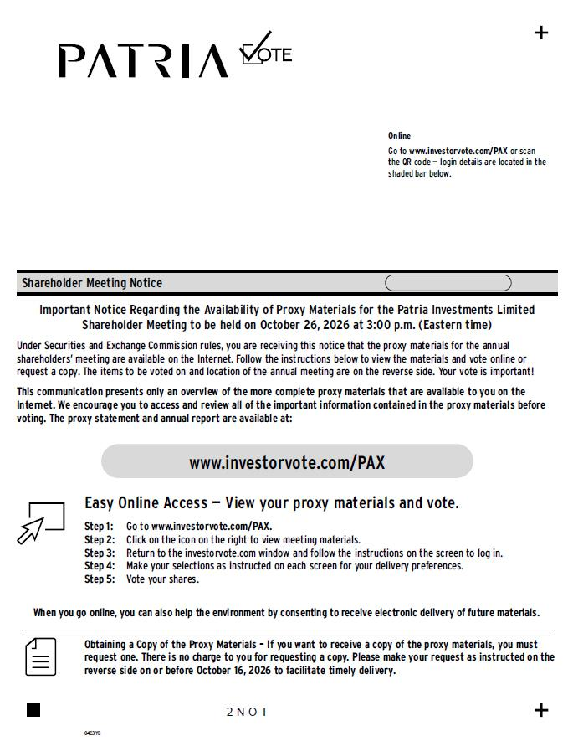
Step 1: Go to www.investorvote.com/PAX. Step 2: Click on the icon on the right to view meeting materials. Step 3: Return to the investorvote.com window and follow the instructions on the screen to log in. Online Go to www.investorvote.com/PAX or scan the QR code — login details are located in the shaded bar below. Shareholder Meeting Notice 04C3YB Important Notice Regarding the Availability of Proxy Materials for the Patria Investments Limited Shareholder Meeting to be held on October 26, 2026 at 3:00 p.m. (Eastern time) Under Securities and Exchange Commission rules, you are receiving this notice that the proxy materials for the annual shareholders’ meeting are available on the Internet. Follow the instructions below to view the materials and vote online or request a copy. The items to be voted on and location of the annual meeting are on the reverse side. Your vote is important! This communication presents only an overview of the more complete proxy materials that are available to you on the Internet. We encourage you to access and review all of the important information contained in the proxy materials before voting. The proxy statement and annual report are available at: Obtaining a Copy of the Proxy Materials – If you want to receive a copy of the proxy materials, you must request one. There is no charge to you for requesting a copy. Please make your request as instructed on the reverse side on or before October 16, 2026 to facilitate timely delivery. 2 N O T Easy Online Access — View your proxy materials and vote. When you go online, you can also help the environment by consenting to receive electronic delivery of future materials. Step 4: Make your selections as instructed on each screen for your delivery preferences. Step 5: Vote your shares.

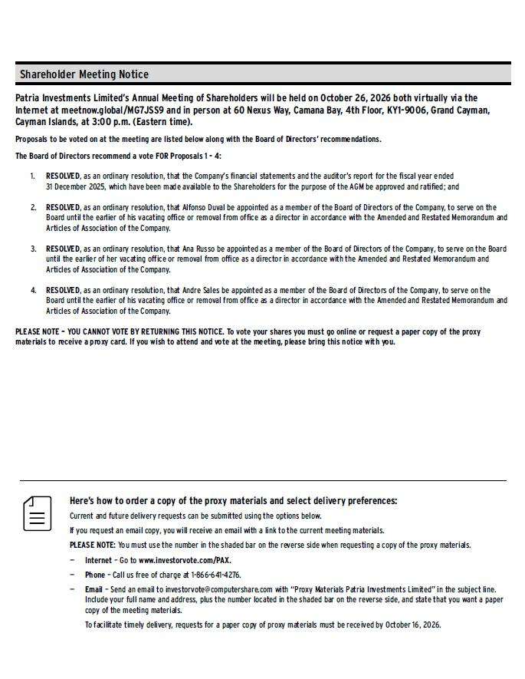
Shareholder Meeting Notice Patria Investments Limited’s Annual Meeting of Shareholders will be held on October 26, 2026 both virtually via the Internet at meetnow.global/MG7JSS9 and in person at 60 Nexus Way, Camana Bay, 4th Floor, KY1-9006, Grand Cayman, Cayman Islands, at 3:00 p.m. (Eastern time). Proposals to be voted on at the meeting are listed below along with the Board of Directors’ recommendations. The Board of Directors recommend a vote FOR Proposals 1 - 4: 1. RESOLVED, as an ordinary resolution, that the Company’s financial statements and the auditor’s report for the fiscal year ended 31 December 2025, which have been made available to the Shareholders for the purpose of the AGM be approved and ratified; and 2. RESOLVED, as an ordinary resolution, that Alfonso Duval be appointed as a member of the Board of Directors of the Company, to serve on the Board until the earlier of his vacating office or removal from office as a director in accordance with the Amended and Restated Memorandum and Articles of Association of the Company. 3. RESOLVED, as an ordinary resolution, that Ana Russo be appointed as a member of the Board of Directors of the Company, to serve on the Board until the earlier of her vacating office or removal from office as a director in accordance with the Amended and Restated Memorandum and Articles of Association of the Company. 4. RESOLVED, as an ordinary resolution, that Andre Sales be appointed as a member of the Board of Directors of the Company, to serve on the Board until the earlier of his vacating office or removal from office as a director in accordance with the Amended and Restated Memorandum and Articles of Association of the Company. PLEASE NOTE – YOU CANNOT VOTE BY RETURNING THIS NOTICE. To vote your shares you must go online or request a paper copy of the proxy materials to receive a proxy card. If you wish to attend and vote at the meeting, please bring this notice with you. Here’s how to order a copy of the proxy materials and select delivery preferences: Current and future delivery requests can be submitted using the options below. If you request an email copy, you will receive an email with a link to the current meeting materials. PLEASE NOTE: You must use the number in the shaded bar on the reverse side when requesting a copy of the proxy materials. — Internet – Go to www.investorvote.com/PAX. — P hone – Call us free of charge at 1-866-641-4276. — Email – Send an email to investorvote@computershare.com with “Proxy Materials Patria Investments Limited” in the subject line. Include your full name and address, plus the number located in the shaded bar on the reverse side, and state that you want a paper copy of the meeting materials. To facilitate timely delivery, requests for a paper copy of proxy materials must be received by October 16, 2026.

