UNITED STATES
SECURITIES AND EXCHANGE COMMISSION
Washington, D.C. 20549

FORM 6-K

REPORT OF FOREIGN PRIVATE ISSUER PURSUANT TO RULE 13a-16 OR 15d-16 UNDER THE SECURITIES EXCHANGE ACT OF 1934

For the month of July 2026

Commission File Number: 001-39911

Patria Investments Limited
(Exact name of registrant as specified in its charter)

60 Nexus Way, 4th floor,
Camana Bay, PO Box 757, KY1-9006
Grand Cayman, Cayman Islands
+1 345 640 4900
(Address of principal executive office)

Indicate by check mark whether the registrant files or will file annual reports under cover of Form 20-F or Form 40-F:

Form 20-F |  |  | X |  |  |  |  |  | Form 40-F

#98358435v1

SIGNATURE

Pursuant to the requirements of the Securities Exchange Act of 1934, the registrant has duly caused this report to be signed on its behalf by the undersigned, thereunto duly authorized.

 |  |  |  |  |  |  |  |  | Patria Investments Limited
 |  |  |  |  |  |  |  |  | By: |  |  | /s/ Raphael Denadai
 |  |  |  |  |  |  |  |  |  |  |  | Name: |  |  | Raphael Denadai
 |  |  |  |  |  |  |  |  |  |  |  | Title: |  |  | Chief Financial Officer
Date: July 31, 2026

TABLE OF CONTENTS

EXHIBIT
99.1 |  |  | Press release dated July 31, 2026 – Patria Reports Second Quarter 2026 Earnings Results.
99.2 |  |  | Patria 2026 2Q Earnings Presentation.

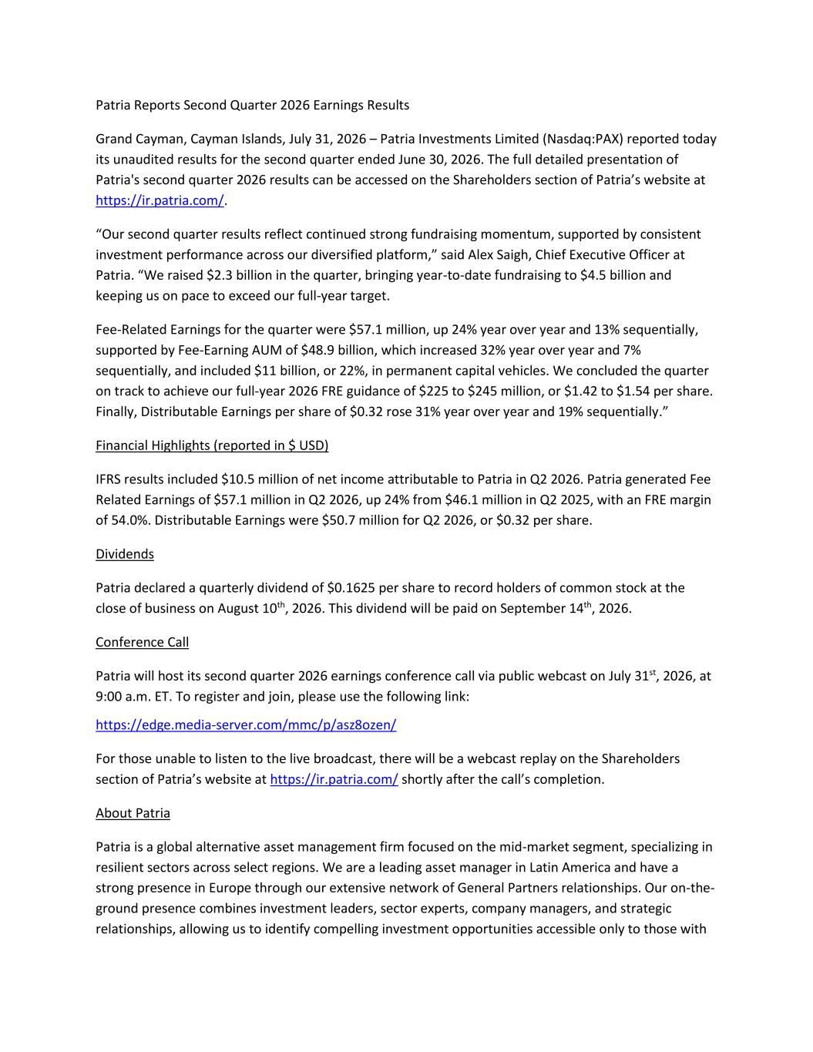

Patria Reports Second Quarter 2026 Earnings Results Grand Cayman, Cayman Islands, July 31, 2026 – Patria Investments Limited (Nasdaq:PAX) reported today its unaudited results for the second quarter ended June 30, 2026. The full detailed presentation of Patria's second quarter 2026 results can be accessed on the Shareholders section of Patria’s website at https://ir.patria.com/. “Our second quarter results reflect continued strong fundraising momentum, supported by consistent investment performance across our diversified platform,” said Alex Saigh, Chief Executive Officer at Patria. “We raised $2.3 billion in the quarter, bringing year-to-date fundraising to $4.5 billion and keeping us on pace to exceed our full-year target. Fee-Related Earnings for the quarter were $57.1 million, up 24% year over year and 13% sequentially, supported by Fee-Earning AUM of $48.9 billion, which increased 32% year over year and 7% sequentially, and included $11 billion, or 22%, in permanent capital vehicles. We concluded the quarter on track to achieve our full-year 2026 FRE guidance of $225 to $245 million, or $1.42 to $1.54 per share. Finally, Distributable Earnings per share of $0.32 rose 31% year over year and 19% sequentially.” Financial Highlights (reported in $ USD) IFRS results included $10.5 million of net income attributable to Patria in Q2 2026. Patria generated Fee Related Earnings of $57.1 million in Q2 2026, up 24% from $46.1 million in Q2 2025, with an FRE margin of 54.0%. Distributable Earnings were $50.7 million for Q2 2026, or $0.32 per share. Dividends Patria declared a quarterly dividend of $0.1625 per share to record holders of common stock at the close of business on August 10th, 2026. This dividend will be paid on September 14th, 2026. Conference Call Patria will host its second quarter 2026 earnings conference call via public webcast on July 31st, 2026, at 9:00 a.m. ET. To register and join, please use the following link: https://edge.media-server.com/mmc/p/asz8ozen/ For those unable to listen to the live broadcast, there will be a webcast replay on the Shareholders section of Patria’s website at https://ir.patria.com/ shortly after the call’s completion. About Patria Patria is a global alternative asset management firm focused on the mid-market segment, specializing in resilient sectors across select regions. We are a leading asset manager in Latin America and have a strong presence in Europe through our extensive network of General Partners relationships. Our on-the- ground presence combines investment leaders, sector experts, company managers, and strategic relationships, allowing us to identify compelling investment opportunities accessible only to those with


local proficiency. With over 37 years of experience and more than $62 billion in assets under management, we believe we consistently deliver attractive returns through long-term investments, while promoting inclusive and sustainable development in the regions where we operate. Further information is available at www.patria.com. Asset Classes: Infrastructure, Credit, Real Estate, Private Equity, Solutions (GPMS), and Public Equities Main sectors: Agribusiness, Power & Energy, Healthcare, Logistics & Transportation, Food & Beverage and Digital & Tech Services Investment Regions: Latin America, Europe and the U.S. Forward-Looking Statements This press release may contain forward-looking statements within the meaning of Section 27A of the Securities Act of 1933, as amended, and Section 21E of the Securities Exchange Act of 1934, as amended. You can identify these forward-looking statements by the use of words such as “outlook,” “indicator,” “believes,” “expects,” “potential,” “continues,” “may,” “will,” “could,” “should,” “seeks,” “approximately,” “predicts,” “intends,” “plans,” “estimates,” “anticipates” or the negative version of these words or other comparable words, among others. Forward-looking statements appear in a number of places in this press release and include, but are not limited to, statements regarding our intent, belief or current expectations. Forward-looking statements are based on our management’s beliefs and assumptions and on information currently available to our management. Forward-looking statements speak only as of the date they are made, and we do not undertake any obligation to update them in light of new information or future developments or to release publicly any revisions to these statements in order to reflect later events or circumstances or to reflect the occurrence of unanticipated events. Such forward-looking statements are subject to various risks and uncertainties. Accordingly, there are or will be important factors that could cause actual outcomes or results to differ materially from those indicated in these statements. Further information on these and other factors that could affect our financial results is included in filings we have made and will make with the U.S. Securities and Exchange Commission from time to time, including but not limited to those described under the section entitled “Risk Factors” in our most recent annual report on Form 20-F, as such factors may be updated from time to time in our periodic filings with the United States Securities and Exchange Commission (“SEC”), which are accessible on the SEC’s website at www.sec.gov. These factors should not be construed as exhaustive and should be read in conjunction with the other cautionary statements that are included in our periodic filings. Contact Patria Shareholder Relations E. PatriaShareholderRelations@patria.com Media - Burson E. patria@hillandknowlton.com / T. +44 20 7113 3468


July 31, 2026 PATRIA INVESTMENTS (NASDAQ: PAX) 2Q26 Earnings Presentation

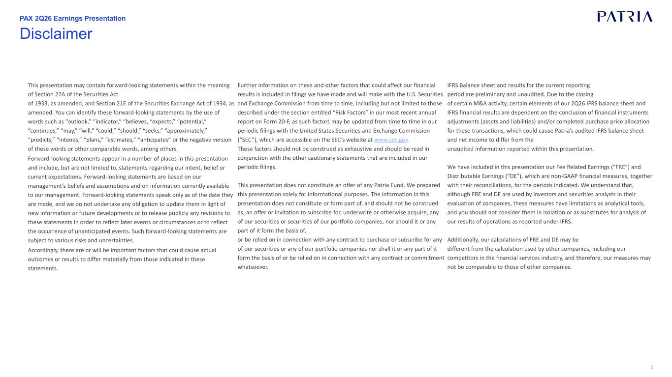
2 This presentation may contain forward-looking statements within the meaning of Section 27A of the Securities Act of 1933, as amended, and Section 21E of the Securities Exchange Act of 1934, as amended. You can identify these forward-looking statements by the use of words such as “outlook,” “indicator,” “believes, “expects,” “potential,” “continues,” “may,” “will,” “could,” “should,” “seeks,” “approximately,” “predicts,” “intends,” “plans,” “estimates,” “anticipates” or the negative version of these words or other comparable words, among others. Forward-looking statements appear in a number of places in this presentation and include, but are not limited to, statements regarding our intent, belief or current expectations. Forward-looking statements are based on our management’s beliefs and assumptions and on information currently available to our management. Forward-looking statements speak only as of the date they are made, and we do not undertake any obligation to update them in light of new information or future developments or to release publicly any revisions to these statements in order to reflect later events or circumstances or to reflect the occurrence of unanticipated events. Such forward-looking statements are subject to various risks and uncertainties. Accordingly, there are or will be important factors that could cause actual outcomes or results to differ materially from those indicated in these statements. Further information on these and other factors that could affect our financial results is included in filings we have made and will make with the U.S. Securities and Exchange Commission from time to time, including but not limited to those described under the section entitled “Risk Factors” in our most recent annual report on Form 20-F, as such factors may be updated from time to time in our periodic filings with the United States Securities and Exchange Commission (“SEC”), which are accessible on the SEC’s website at www.sec.gov. These factors should not be construed as exhaustive and should be read in conjunction with the other cautionary statements that are included in our periodic filings. This presentation does not constitute an offer of any Patria Fund. We prepared this presentation solely for informational purposes. The information in this presentation does not constitute or form part of, and should not be construed as, an offer or invitation to subscribe for, underwrite or otherwise acquire, any of our securities or securities of our portfolio companies, nor should it or any part of it form the basis of, or be relied on in connection with any contract to purchase or subscribe for any of our securities or any of our portfolio companies nor shall it or any part of it form the basis of or be relied on in connection with any contract or commitment whatsoever. IFRS Balance sheet and results for the current reporting period are preliminary and unaudited. Due to the closing of certain M&A activity, certain elements of our 2Q26 IFRS balance sheet and IFRS financial results are dependent on the conclusion of financial instruments adjustments (assets and liabilities) and/or completed purchase price allocation for these transactions, which could cause Patria’s audited IFRS balance sheet and net income to differ from the unaudited information reported within this presentation. We have included in this presentation our Fee Related Earnings (“FRE”) and Distributable Earnings (“DE”), which are non-GAAP financial measures, together with their reconciliations, for the periods indicated. We understand that, although FRE and DE are used by investors and securities analysts in their evaluation of companies, these measures have limitations as analytical tools, and you should not consider them in isolation or as substitutes for analysis of our results of operations as reported under IFRS. Additionally, our calculations of FRE and DE may be different from the calculation used by other companies, including our competitors in the financial services industry, and therefore, our measures may not be comparable to those of other companies. Disclaimer PAX 2Q26 Earnings Presentation

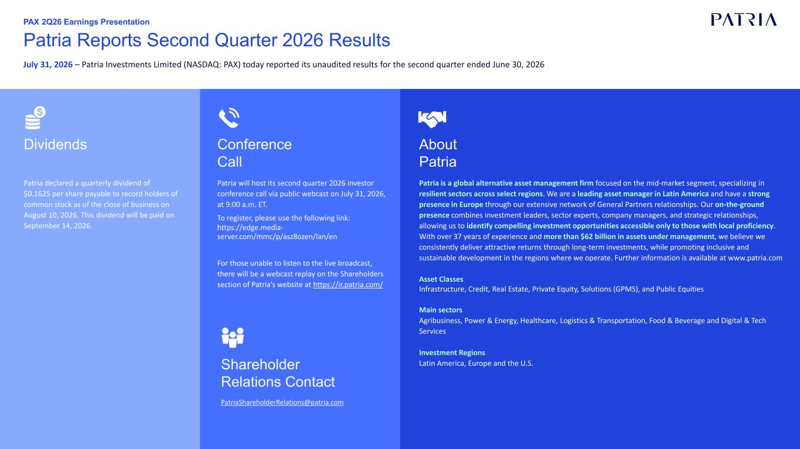
3 Patria Reports Second Quarter 2026 Results July 31, 2026 – Patria Investments Limited (NASDAQ: PAX) today reported its unaudited results for the second quarter ended June 30, 2026 Patria will host its second quarter 2026 investor conference call via public webcast on July 31, 2026, at 9:00 a.m. ET. To register, please use the following link: https://edge.media- server.com/mmc/p/asz8ozen/lan/en For those unable to listen to the live broadcast, there will be a webcast replay on the Shareholders section of Patria’s website at https://ir.patria.com/ Conference Call Dividends Shareholder Relations Contact PatriaShareholderRelations@patria.com About Patria Patria is a global alternative asset management firm focused on the mid-market segment, specializing in resilient sectors across select regions. We are a leading asset manager in Latin America and have a strong presence in Europe through our extensive network of General Partners relationships. Our on-the-ground presence combines investment leaders, sector experts, company managers, and strategic relationships, allowing us to identify compelling investment opportunities accessible only to those with local proficiency. With over 37 years of experience and more than $62 billion in assets under management, we believe we consistently deliver attractive returns through long-term investments, while promoting inclusive and sustainable development in the regions where we operate. Further information is available at www.patria.com Asset Classes Infrastructure, Credit, Real Estate, Private Equity, Solutions (GPMS), and Public Equities Main sectors Agribusiness, Power & Energy, Healthcare, Logistics & Transportation, Food & Beverage and Digital & Tech Services Investment Regions Latin America, Europe and the U.S. Patria declared a quarterly dividend of $0.1625 per share payable to record holders of common stock as of the close of business on August 10, 2026. This dividend will be paid on September 14, 2026. PAX 2Q26 Earnings Presentation

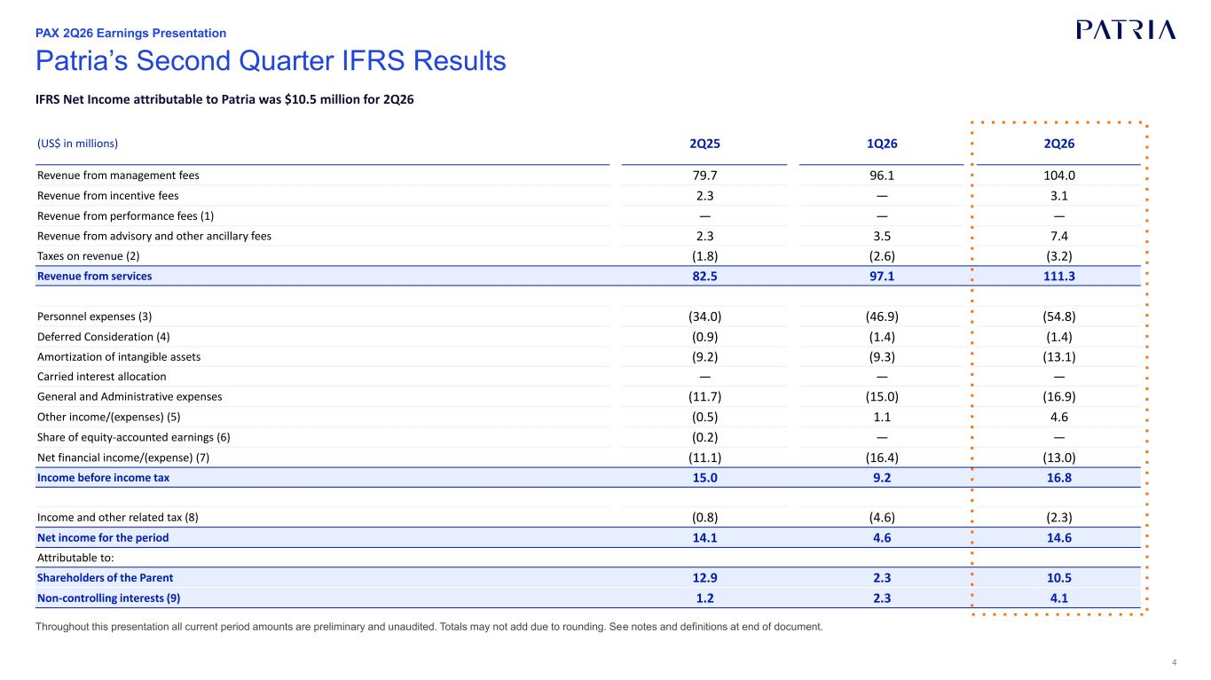
4 Throughout this presentation all current period amounts are preliminary and unaudited. Totals may not add due to rounding. See notes and definitions at end of document. Patria’s Second Quarter IFRS Results IFRS Net Income attributable to Patria was $10.5 million for 2Q26 PAX 2Q26 Earnings Presentation (US$ in millions) 2Q25 1Q26 2Q26 Revenue from management fees 79.7 96.1 104.0 Revenue from incentive fees 2.3 — 3.1 Revenue from performance fees (1) — — — Revenue from advisory and other ancillary fees 2.3 3.5 7.4 Taxes on revenue (2) (1.8) (2.6) (3.2) Revenue from services 82.5 97.1 111.3 Personnel expenses (3) (34.0) (46.9) (54.8) Deferred Consideration (4) (0.9) (1.4) (1.4) Amortization of intangible assets (9.2) (9.3) (13.1) Carried interest allocation — — — General and Administrative expenses (11.7) (15.0) (16.9) Other income/(expenses) (5) (0.5) 1.1 4.6 Share of equity-accounted earnings (6) (0.2) — — Net financial income/(expense) (7) (11.1) (16.4) (13.0) Income before income tax 15.0 9.2 16.8 Income and other related tax (8) (0.8) (4.6) (2.3) Net income for the period 14.1 4.6 14.6 Attributable to: Shareholders of the Parent 12.9 2.3 10.5 Non-controlling interests (9) 1.2 2.3 4.1

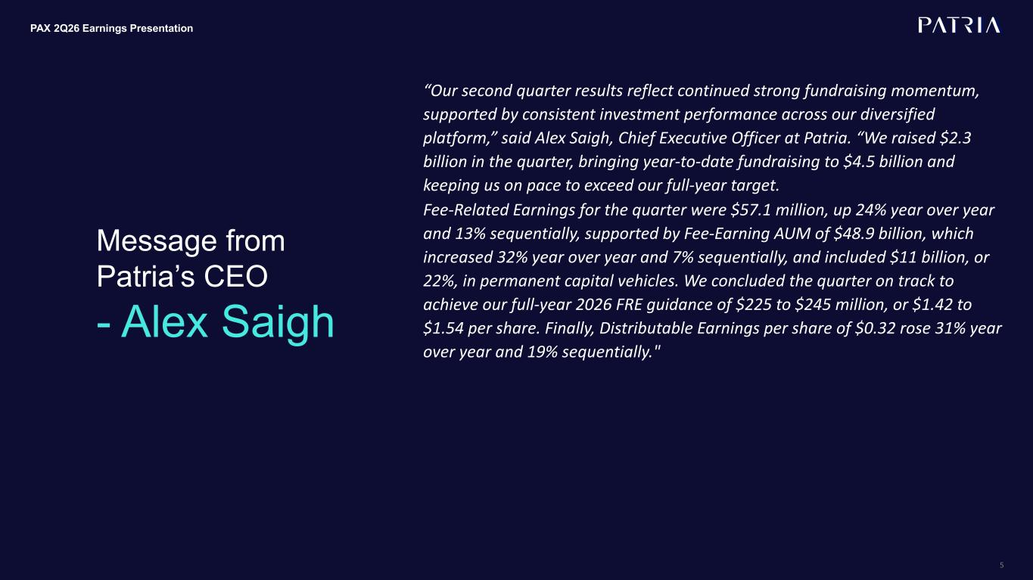
5 PAX 2Q26 Earnings Presentation Message from Patria’s CEO - Alex Saigh “Our second quarter results reflect continued strong fundraising momentum, supported by consistent investment performance across our diversified platform,” said Alex Saigh, Chief Executive Officer at Patria. “We raised $2.3 billion in the quarter, bringing year-to-date fundraising to $4.5 billion and keeping us on pace to exceed our full-year target. Fee-Related Earnings for the quarter were $57.1 million, up 24% year over year and 13% sequentially, supported by Fee-Earning AUM of $48.9 billion, which increased 32% year over year and 7% sequentially, and included $11 billion, or 22%, in permanent capital vehicles. We concluded the quarter on track to achieve our full-year 2026 FRE guidance of $225 to $245 million, or $1.42 to $1.54 per share. Finally, Distributable Earnings per share of $0.32 rose 31% year over year and 19% sequentially."

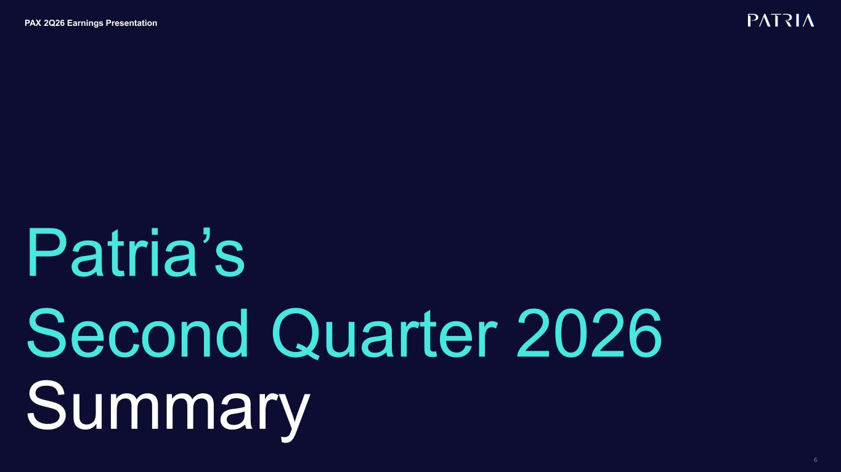
6 Patria’s Second Quarter 2026 Summary PAX 2Q26 Earnings Presentation

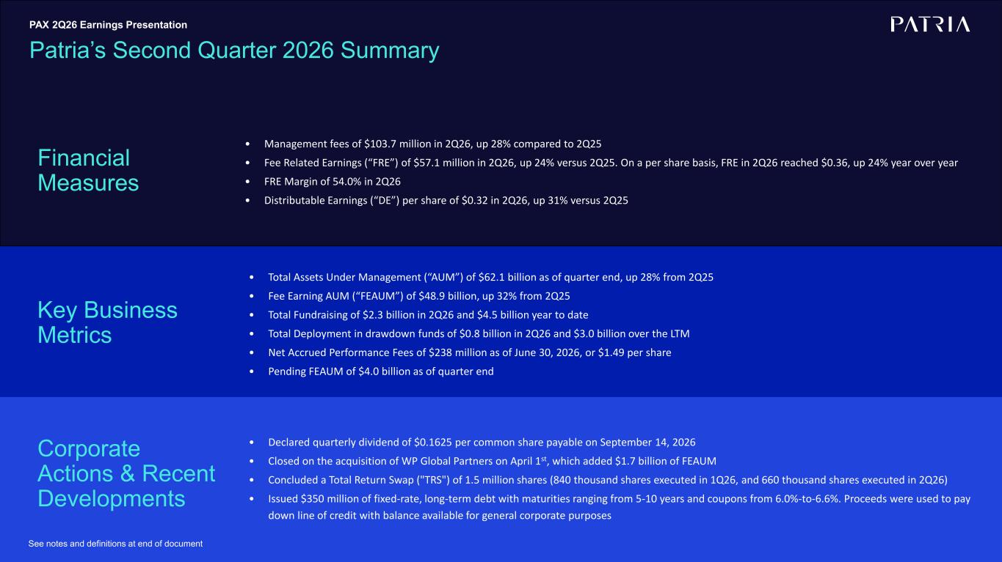
7 Key Business Metrics Financial Measures • Management fees of $103.7 million in 2Q26, up 28% compared to 2Q25 • Fee Related Earnings (“FRE”) of $57.1 million in 2Q26, up 24% versus 2Q25. On a per share basis, FRE in 2Q26 reached $0.36, up 24% year over year • FRE Margin of 54.0% in 2Q26 • Distributable Earnings (“DE”) per share of $0.32 in 2Q26, up 31% versus 2Q25 See notes and definitions at end of document • Total Assets Under Management (“AUM”) of $62.1 billion as of quarter end, up 28% from 2Q25 • Fee Earning AUM (“FEAUM”) of $48.9 billion, up 32% from 2Q25 • Total Fundraising of $2.3 billion in 2Q26 and $4.5 billion year to date • Total Deployment in drawdown funds of $0.8 billion in 2Q26 and $3.0 billion over the LTM • Net Accrued Performance Fees of $238 million as of June 30, 2026, or $1.49 per share • Pending FEAUM of $4.0 billion as of quarter end Corporate Actions & Recent Developments Patria’s Second Quarter 2026 Summary PAX 2Q26 Earnings Presentation • Declared quarterly dividend of $0.1625 per common share payable on September 14, 2026 • Closed on the acquisition of WP Global Partners on April 1st, which added $1.7 billion of FEAUM • Concluded a Total Return Swap ("TRS") of 1.5 million shares (840 thousand shares executed in 1Q26, and 660 thousand shares executed in 2Q26) • Issued $350 million of fixed-rate, long-term debt with maturities ranging from 5-10 years and coupons from 6.0%-to-6.6%. Proceeds were used to pay down line of credit with balance available for general corporate purposes

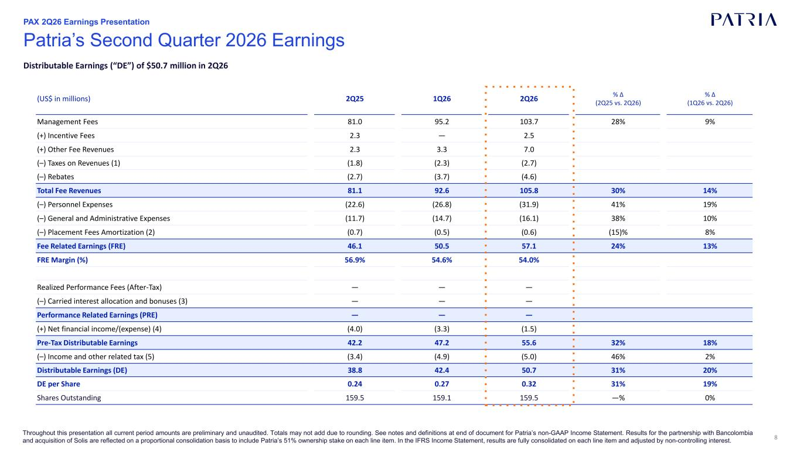
8 Throughout this presentation all current period amounts are preliminary and unaudited. Totals may not add due to rounding. See notes and definitions at end of document for Patria’s non-GAAP Income Statement. Results for the partnership with Bancolombia and acquisition of Solis are reflected on a proportional consolidation basis to include Patria’s 51% ownership stake on each line item. In the IFRS Income Statement, results are fully consolidated on each line item and adjusted by non-controlling interest. (US$ in millions) 2Q25 1Q26 2Q26 % Δ (2Q25 vs. 2Q26) % Δ (1Q26 vs. 2Q26) Management Fees 81.0 95.2 103.7 28% 9% (+) Incentive Fees 2.3 — 2.5 (+) Other Fee Revenues 2.3 3.3 7.0 (–) Taxes on Revenues (1) (1.8) (2.3) (2.7) (–) Rebates (2.7) (3.7) (4.6) Total Fee Revenues 81.1 92.6 105.8 30% 14% (–) Personnel Expenses (22.6) (26.8) (31.9) 41% 19% (–) General and Administrative Expenses (11.7) (14.7) (16.1) 38% 10% (–) Placement Fees Amortization (2) (0.7) (0.5) (0.6) (15)% 8% Fee Related Earnings (FRE) 46.1 50.5 57.1 24% 13% FRE Margin (%) 56.9% 54.6% 54.0% Realized Performance Fees (After-Tax) — — — (–) Carried interest allocation and bonuses (3) — — — Performance Related Earnings (PRE) — — — (+) Net financial income/(expense) (4) (4.0) (3.3) (1.5) Pre-Tax Distributable Earnings 42.2 47.2 55.6 32% 18% (–) Income and other related tax (5) (3.4) (4.9) (5.0) 46% 2% Distributable Earnings (DE) 38.8 42.4 50.7 31% 20% DE per Share 0.24 0.27 0.32 31% 19% Shares Outstanding 159.5 159.1 159.5 —% 0% Patria’s Second Quarter 2026 Earnings Distributable Earnings (“DE”) of $50.7 million in 2Q26 PAX 2Q26 Earnings Presentation

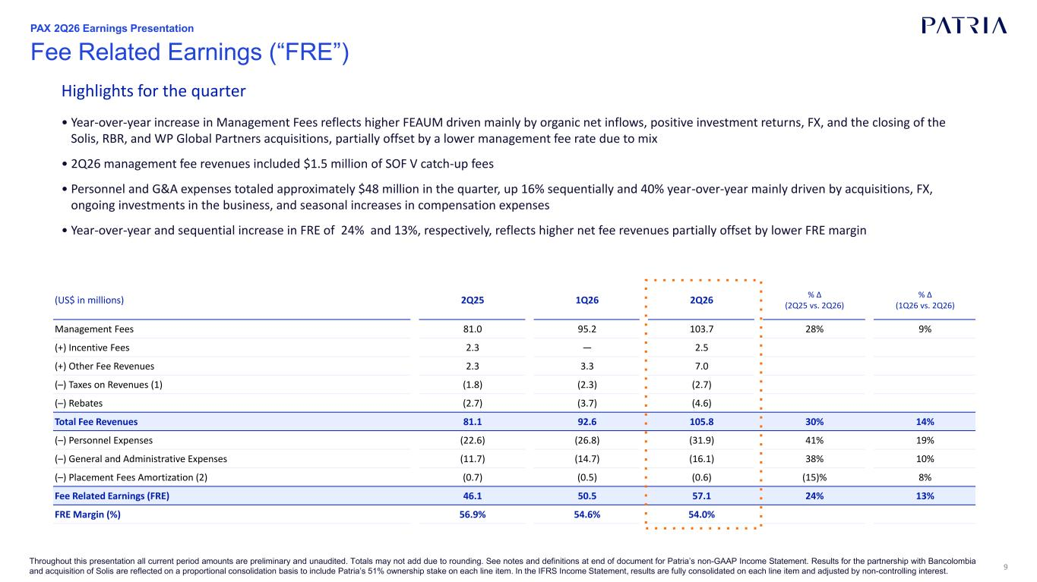
9 Highlights for the quarter • Year-over-year increase in Management Fees reflects higher FEAUM driven mainly by organic net inflows, positive investment returns, FX, and the closing of the Solis, RBR, and WP Global Partners acquisitions, partially offset by a lower management fee rate due to mix • 2Q26 management fee revenues included $1.5 million of SOF V catch-up fees • Personnel and G&A expenses totaled approximately $48 million in the quarter, up 16% sequentially and 40% year-over-year mainly driven by acquisitions, FX, ongoing investments in the business, and seasonal increases in compensation expenses • Year-over-year and sequential increase in FRE of 24% and 13%, respectively, reflects higher net fee revenues partially offset by lower FRE margin (US$ in millions) 2Q25 1Q26 2Q26 % Δ (2Q25 vs. 2Q26) % Δ (1Q26 vs. 2Q26) Management Fees 81.0 95.2 103.7 28% 9% (+) Incentive Fees 2.3 — 2.5 (+) Other Fee Revenues 2.3 3.3 7.0 (–) Taxes on Revenues (1) (1.8) (2.3) (2.7) (–) Rebates (2.7) (3.7) (4.6) Total Fee Revenues 81.1 92.6 105.8 30% 14% (–) Personnel Expenses (22.6) (26.8) (31.9) 41% 19% (–) General and Administrative Expenses (11.7) (14.7) (16.1) 38% 10% (–) Placement Fees Amortization (2) (0.7) (0.5) (0.6) (15)% 8% Fee Related Earnings (FRE) 46.1 50.5 57.1 24% 13% FRE Margin (%) 56.9% 54.6% 54.0% Throughout this presentation all current period amounts are preliminary and unaudited. Totals may not add due to rounding. See notes and definitions at end of document for Patria’s non-GAAP Income Statement. Results for the partnership with Bancolombia and acquisition of Solis are reflected on a proportional consolidation basis to include Patria’s 51% ownership stake on each line item. In the IFRS Income Statement, results are fully consolidated on each line item and adjusted by non-controlling interest. Fee Related Earnings (“FRE”) PAX 2Q26 Earnings Presentation

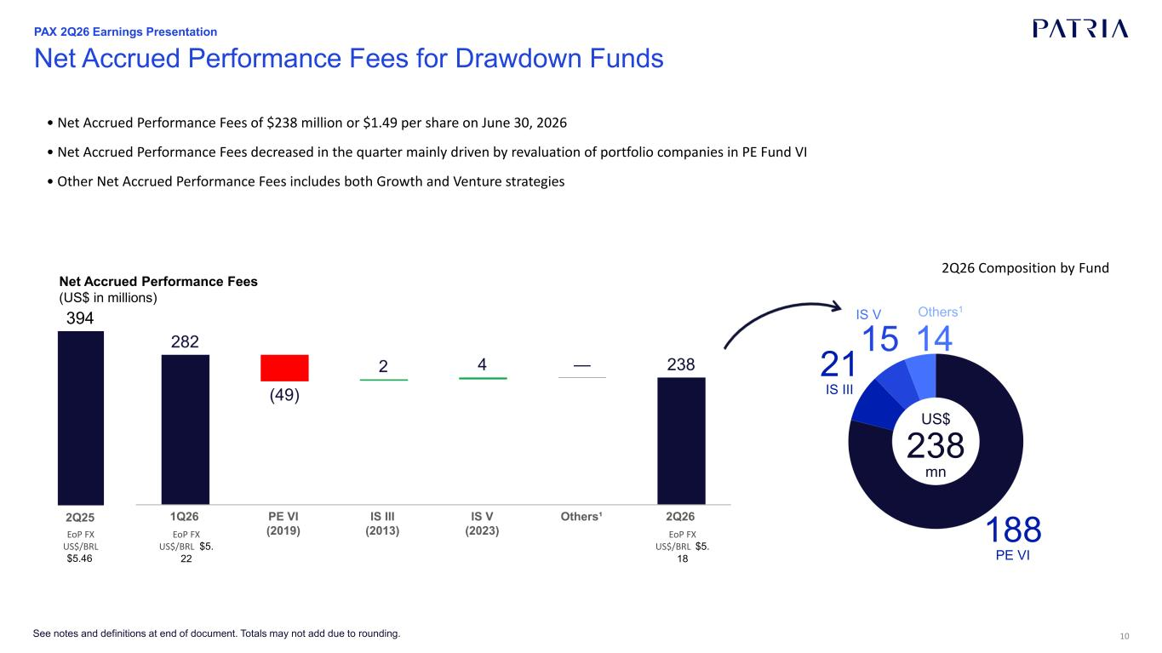
10 Net Accrued Performance Fees for Drawdown Funds US$ 238 mn 188 PE VI 21 IS III IS V Others1 EoP FX US$/BRL $5. 18 EoP FX US$/BRL $5.46 Net Accrued Performance Fees (US$ in millions) EoP FX US$/BRL $5. 22 See notes and definitions at end of document. Totals may not add due to rounding. 2Q26 Composition by Fund PAX 2Q26 Earnings Presentation • Net Accrued Performance Fees of $238 million or $1.49 per share on June 30, 2026 • Net Accrued Performance Fees decreased in the quarter mainly driven by revaluation of portfolio companies in PE Fund VI • Other Net Accrued Performance Fees includes both Growth and Venture strategies

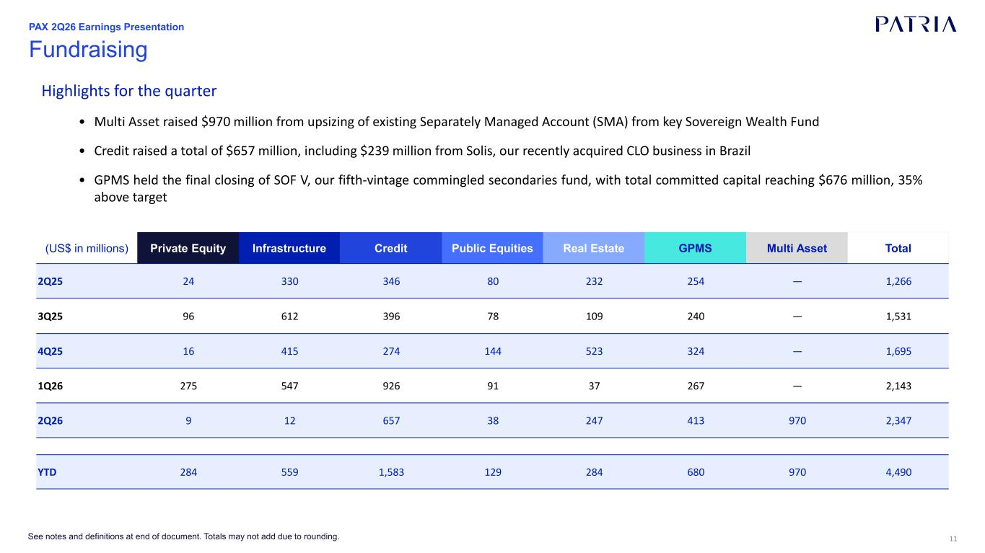
11 (US$ in millions) Private Equity Infrastructure Credit Public Equities Real Estate GPMS Multi Asset Total 2Q25 24 330 346 80 232 254 — 1,266 3Q25 96 612 396 78 109 240 — 1,531 4Q25 16 415 274 144 523 324 — 1,695 1Q26 275 547 926 91 37 267 — 2,143 2Q26 9 12 657 38 247 413 970 2,347 YTD 284 559 1,583 129 284 680 970 4,490 Fundraising See notes and definitions at end of document. Totals may not add due to rounding. Highlights for the quarter • Multi Asset raised $970 million from upsizing of existing Separately Managed Account (SMA) from key Sovereign Wealth Fund • Credit raised a total of $657 million, including $239 million from Solis, our recently acquired CLO business in Brazil • GPMS held the final closing of SOF V, our fifth-vintage commingled secondaries fund, with total committed capital reaching $676 million, 35% above target PAX 2Q26 Earnings Presentation

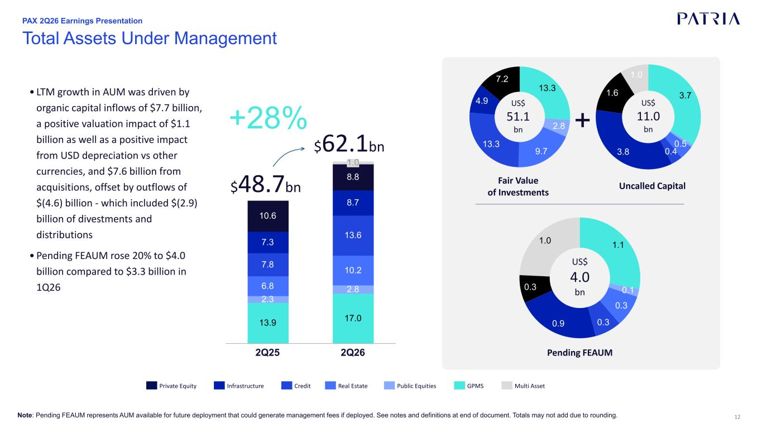
12 Total Assets Under Management Note: Pending FEAUM represents AUM available for future deployment that could generate management fees if deployed. See notes and definitions at end of document. Totals may not add due to rounding. Fair Value of Investments US$ 11.0 bn Uncalled Capital + US$ 51.1 bn+28% $48.7bn $62.1bn GPMSPublic EquitiesReal EstateCreditInfrastructurePrivate Equity • LTM growth in AUM was driven by organic capital inflows of $7.7 billion, a positive valuation impact of $1.1 billion as well as a positive impact from USD depreciation vs other currencies, and $7.6 billion from acquisitions, offset by outflows of $(4.6) billion - which included $(2.9) billion of divestments and distributions • Pending FEAUM rose 20% to $4.0 billion compared to $3.3 billion in 1Q26 Pending FEAUM PAX 2Q26 Earnings Presentation US$ 4.0 bn Multi Asset

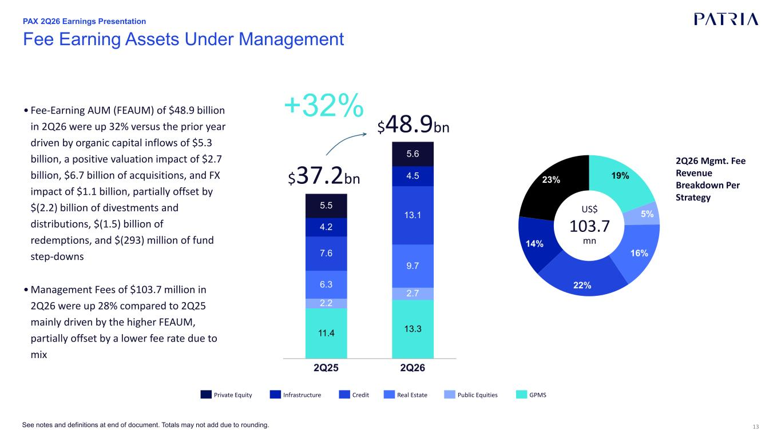
13See notes and definitions at end of document. Totals may not add due to rounding. $37.2bn $48.9bn Fee Earning Assets Under Management US$ 103.7 mn 2Q26 Mgmt. Fee Revenue Breakdown Per Strategy +32% GPMSPublic EquitiesReal EstateCreditInfrastructurePrivate Equity US$ 81.4 mn 4Q24 Mgmt. Fee Revenue Breakdown Per Strategy PAX 2Q26 Earnings Presentation • Fee-Earning AUM (FEAUM) of $48.9 billion in 2Q26 were up 32% versus the prior year driven by organic capital inflows of $5.3 billion, a positive valuation impact of $2.7 billion, $6.7 billion of acquisitions, and FX impact of $1.1 billion, partially offset by $(2.2) billion of divestments and distributions, $(1.5) billion of redemptions, and $(293) million of fund step-downs • Management Fees of $103.7 million in 2Q26 were up 28% compared to 2Q25 mainly driven by the higher FEAUM, partially offset by a lower fee rate due to mix

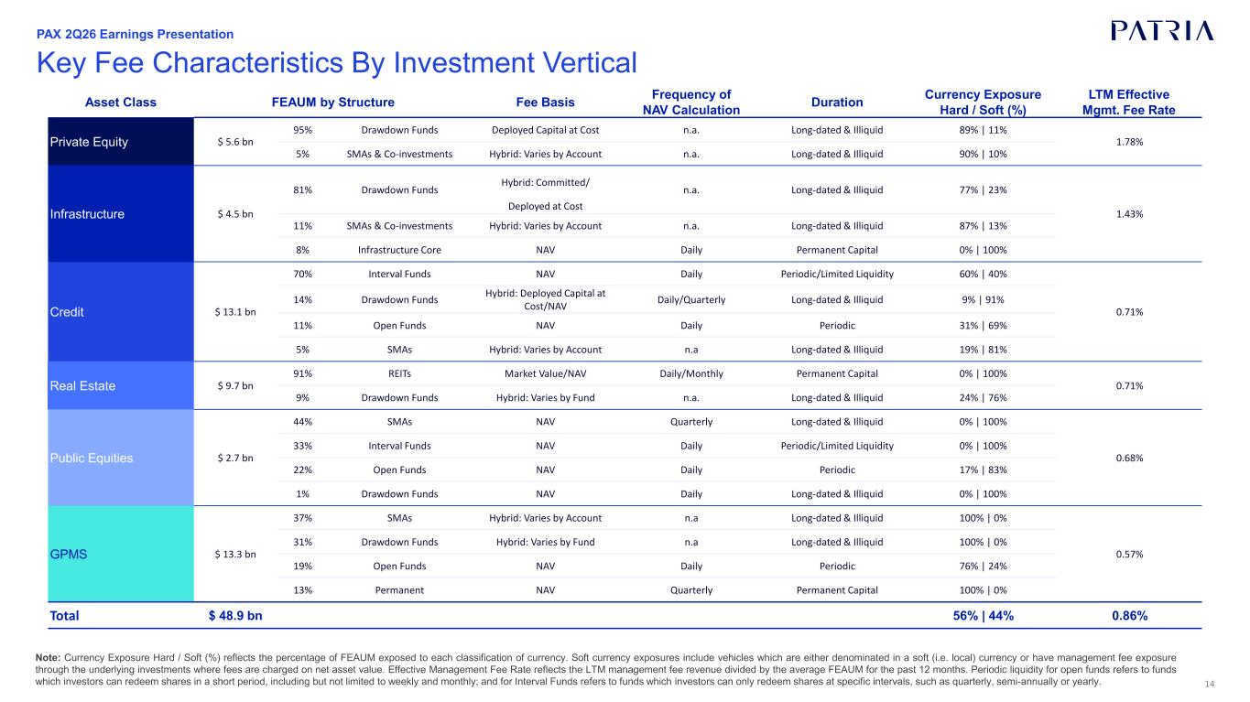
14 Note: Currency Exposure Hard / Soft (%) reflects the percentage of FEAUM exposed to each classification of currency. Soft currency exposures include vehicles which are either denominated in a soft (i.e. local) currency or have management fee exposure through the underlying investments where fees are charged on net asset value. Effective Management Fee Rate reflects the LTM management fee revenue divided by the average FEAUM for the past 12 months. Periodic liquidity for open funds refers to funds which investors can redeem shares in a short period, including but not limited to weekly and monthly; and for Interval Funds refers to funds which investors can only redeem shares at specific intervals, such as quarterly, semi-annually or yearly. Asset Class FEAUM by Structure Fee Basis Frequency of Duration Currency Exposure LTM Effective NAV Calculation Hard / Soft (%) Mgmt. Fee Rate Private Equity $ 5.6 bn 95% Drawdown Funds Deployed Capital at Cost n.a. Long-dated & Illiquid 89% | 11% 1.78% 5% SMAs & Co-investments Hybrid: Varies by Account n.a. Long-dated & Illiquid 90% | 10% Infrastructure $ 4.5 bn 81% Drawdown Funds Hybrid: Committed/ n.a. Long-dated & Illiquid 77% | 23% 1.43% Deployed at Cost 11% SMAs & Co-investments Hybrid: Varies by Account n.a. Long-dated & Illiquid 87% | 13% 8% Infrastructure Core NAV Daily Permanent Capital 0% | 100% Credit $ 13.1 bn 70% Interval Funds NAV Daily Periodic/Limited Liquidity 60% | 40% 0.71% 14% Drawdown Funds Hybrid: Deployed Capital at Cost/NAV Daily/Quarterly Long-dated & Illiquid 9% | 91% 11% Open Funds NAV Daily Periodic 31% | 69% 5% SMAs Hybrid: Varies by Account n.a Long-dated & Illiquid 19% | 81% Real Estate $ 9.7 bn 91% REITs Market Value/NAV Daily/Monthly Permanent Capital 0% | 100% 0.71% 9% Drawdown Funds Hybrid: Varies by Fund n.a. Long-dated & Illiquid 24% | 76% Public Equities $ 2.7 bn 44% SMAs NAV Quarterly Long-dated & Illiquid 0% | 100% 0.68% 33% Interval Funds NAV Daily Periodic/Limited Liquidity 0% | 100% 22% Open Funds NAV Daily Periodic 17% | 83% 1% Drawdown Funds NAV Daily Long-dated & Illiquid 0% | 100% GPMS $ 13.3 bn 37% SMAs Hybrid: Varies by Account n.a Long-dated & Illiquid 100% | 0% 0.57% 31% Drawdown Funds Hybrid: Varies by Fund n.a Long-dated & Illiquid 100% | 0% 19% Open Funds NAV Daily Periodic 76% | 24% 13% Permanent NAV Quarterly Permanent Capital 100% | 0% Total $ 48.9 bn 56% | 44% 0.86% Key Fee Characteristics By Investment Vertical PAX 2Q26 Earnings Presentation

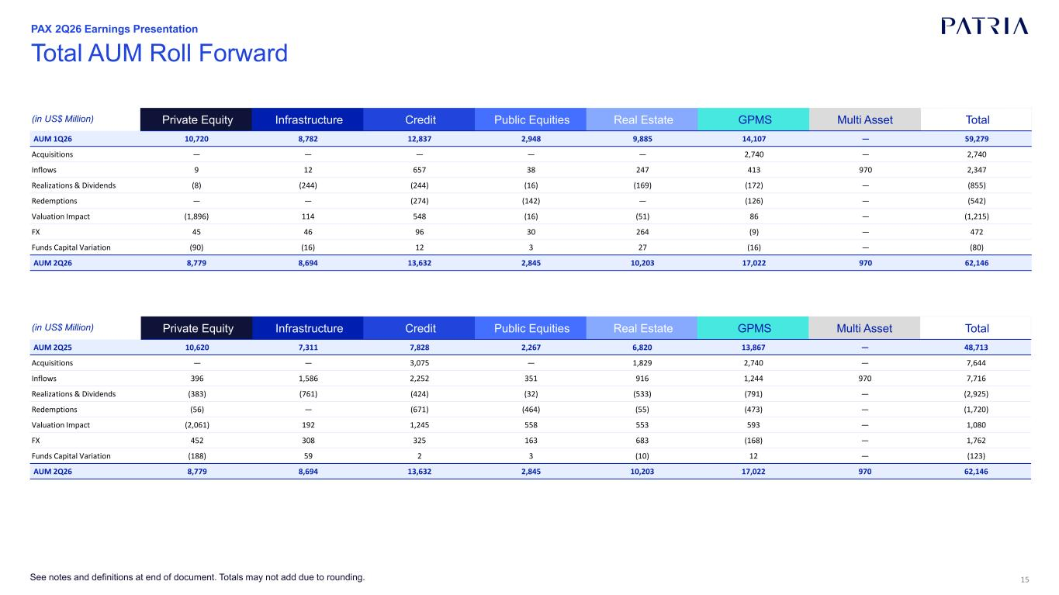
15See notes and definitions at end of document. Totals may not add due to rounding. Total AUM Roll Forward PAX 2Q26 Earnings Presentation (in US$ Million) Private Equity Infrastructure Credit Public Equities Real Estate GPMS Multi Asset Total AUM 1Q26 10,720 8,782 12,837 2,948 9,885 14,107 — 59,279 Acquisitions — — — — — 2,740 — 2,740 Inflows 9 12 657 38 247 413 970 2,347 Realizations & Dividends (8) (244) (244) (16) (169) (172) — (855) Redemptions — — (274) (142) — (126) — (542) Valuation Impact (1,896) 114 548 (16) (51) 86 — (1,215) FX 45 46 96 30 264 (9) — 472 Funds Capital Variation (90) (16) 12 3 27 (16) — (80) AUM 2Q26 8,779 8,694 13,632 2,845 10,203 17,022 970 62,146 (in US$ Million) Private Equity Infrastructure Credit Public Equities Real Estate GPMS Multi Asset Total AUM 2Q25 10,620 7,311 7,828 2,267 6,820 13,867 — 48,713 Acquisitions — — 3,075 — 1,829 2,740 — 7,644 Inflows 396 1,586 2,252 351 916 1,244 970 7,716 Realizations & Dividends (383) (761) (424) (32) (533) (791) — (2,925) Redemptions (56) — (671) (464) (55) (473) — (1,720) Valuation Impact (2,061) 192 1,245 558 553 593 — 1,080 FX 452 308 325 163 683 (168) — 1,762 Funds Capital Variation (188) 59 2 3 (10) 12 — (123) AUM 2Q26 8,779 8,694 13,632 2,845 10,203 17,022 970 62,146

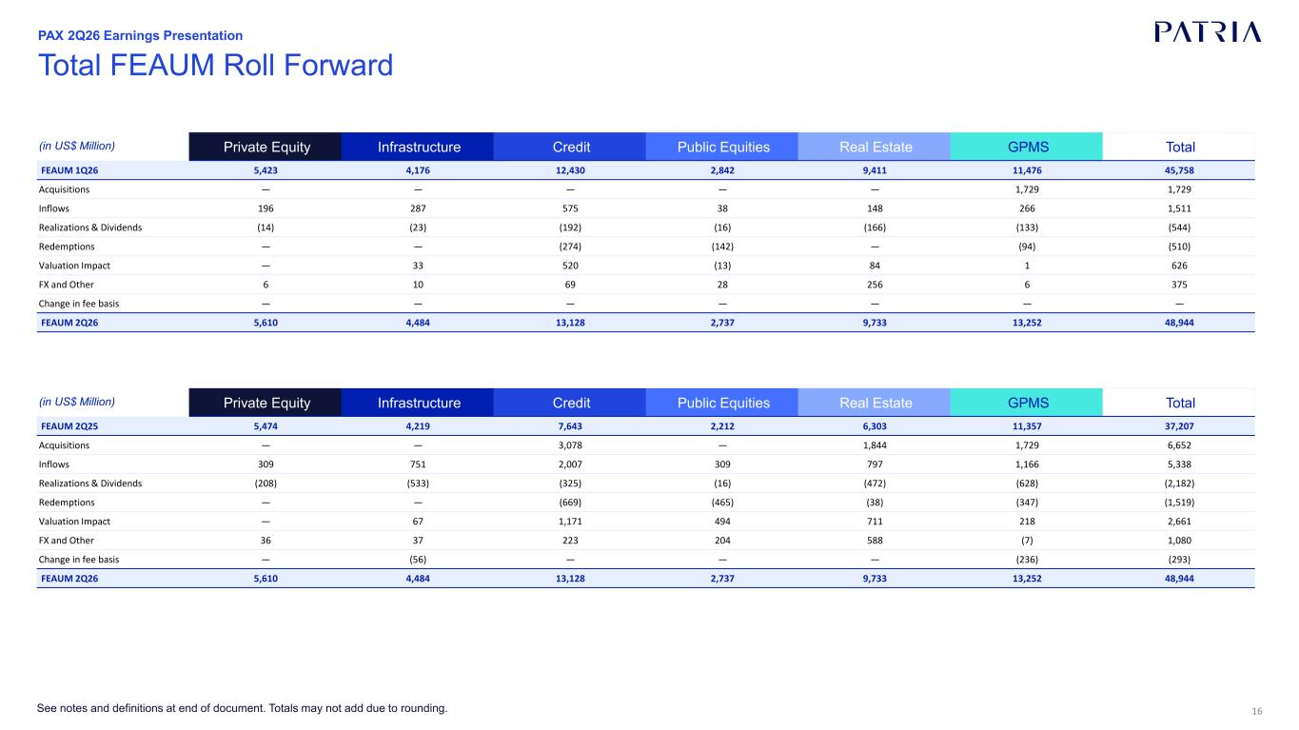
16See notes and definitions at end of document. Totals may not add due to rounding. Total FEAUM Roll Forward PAX 2Q26 Earnings Presentation (in US$ Million) Private Equity Infrastructure Credit Public Equities Real Estate GPMS Total FEAUM 1Q26 5,423 4,176 12,430 2,842 9,411 11,476 45,758 Acquisitions — — — — — 1,729 1,729 Inflows 196 287 575 38 148 266 1,511 Realizations & Dividends (14) (23) (192) (16) (166) (133) (544) Redemptions — — (274) (142) — (94) (510) Valuation Impact — 33 520 (13) 84 1 626 FX and Other 6 10 69 28 256 6 375 Change in fee basis — — — — — — — FEAUM 2Q26 5,610 4,484 13,128 2,737 9,733 13,252 48,944 (in US$ Million) Private Equity Infrastructure Credit Public Equities Real Estate GPMS Total FEAUM 2Q25 5,474 4,219 7,643 2,212 6,303 11,357 37,207 Acquisitions — — 3,078 — 1,844 1,729 6,652 Inflows 309 751 2,007 309 797 1,166 5,338 Realizations & Dividends (208) (533) (325) (16) (472) (628) (2,182) Redemptions — — (669) (465) (38) (347) (1,519) Valuation Impact — 67 1,171 494 711 218 2,661 FX and Other 36 37 223 204 588 (7) 1,080 Change in fee basis — (56) — — — (236) (293) FEAUM 2Q26 5,610 4,484 13,128 2,737 9,733 13,252 48,944

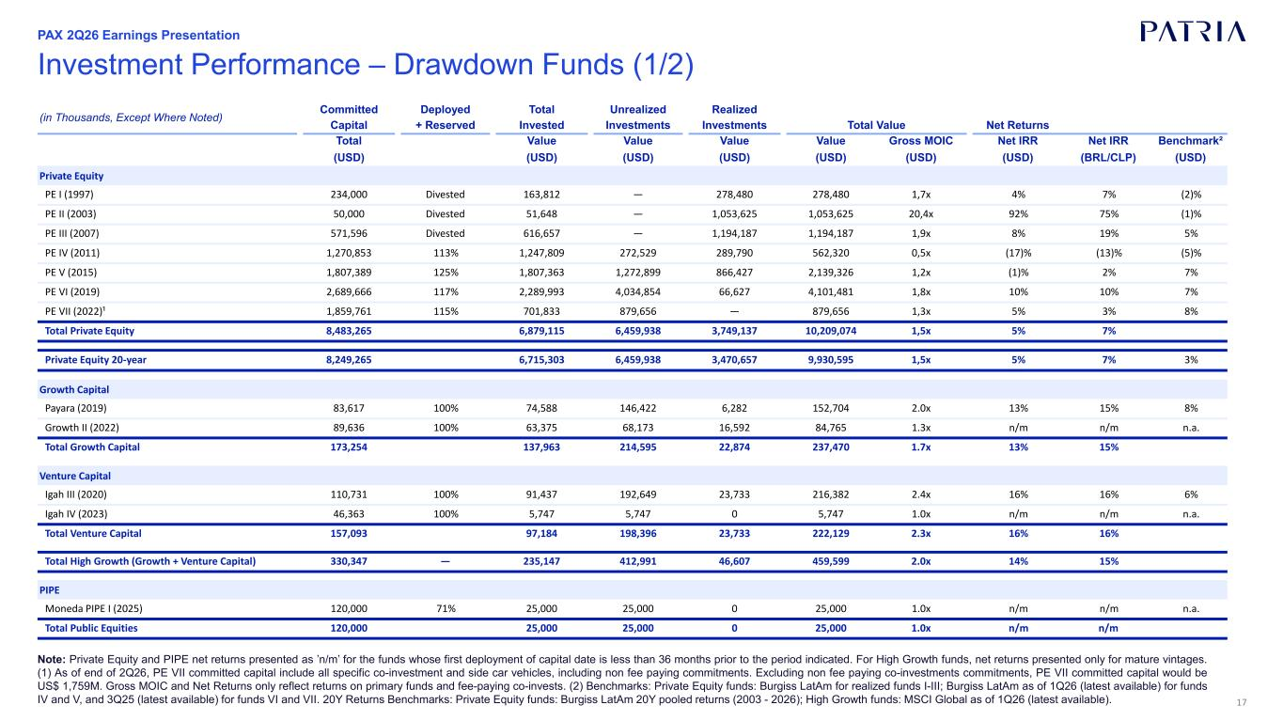
17 Investment Performance – Drawdown Funds (1/2) Note: Private Equity and PIPE net returns presented as ’n/m’ for the funds whose first deployment of capital date is less than 36 months prior to the period indicated. For High Growth funds, net returns presented only for mature vintages. (1) As of end of 2Q26, PE VII committed capital include all specific co-investment and side car vehicles, including non fee paying commitments. Excluding non fee paying co-investments commitments, PE VII committed capital would be US$ 1,759M. Gross MOIC and Net Returns only reflect returns on primary funds and fee-paying co-invests. (2) Benchmarks: Private Equity funds: Burgiss LatAm for realized funds I-III; Burgiss LatAm as of 1Q26 (latest available) for funds IV and V, and 3Q25 (latest available) for funds VI and VII. 20Y Returns Benchmarks: Private Equity funds: Burgiss LatAm 20Y pooled returns (2003 - 2026); High Growth funds: MSCI Global as of 1Q26 (latest available). (in Thousands, Except Where Noted) Committed Deployed Total Unrealized Realized Capital + Reserved Invested Investments Investments Total Value Net Returns Total Value Value Value Value Gross MOIC Net IRR Net IRR Benchmark² (USD) (USD) (USD) (USD) (USD) (USD) (USD) (BRL/CLP) (USD) Private Equity PE I (1997) 234,000 Divested 163,812 — 278,480 278,480 1,7x 4% 7% (2)% PE II (2003) 50,000 Divested 51,648 — 1,053,625 1,053,625 20,4x 92% 75% (1)% PE III (2007) 571,596 Divested 616,657 — 1,194,187 1,194,187 1,9x 8% 19% 5% PE IV (2011) 1,270,853 113% 1,247,809 272,529 289,790 562,320 0,5x (17)% (13)% (5)% PE V (2015) 1,807,389 125% 1,807,363 1,272,899 866,427 2,139,326 1,2x (1)% 2% 7% PE VI (2019) 2,689,666 117% 2,289,993 4,034,854 66,627 4,101,481 1,8x 10% 10% 7% PE VII (2022)¹ 1,859,761 115% 701,833 879,656 — 879,656 1,3x 5% 3% 8% Total Private Equity 8,483,265 6,879,115 6,459,938 3,749,137 10,209,074 1,5x 5% 7% Private Equity 20-year 8,249,265 6,715,303 6,459,938 3,470,657 9,930,595 1,5x 5% 7% 3% Growth Capital Payara (2019) 83,617 100% 74,588 146,422 6,282 152,704 2.0x 13% 15% 8% Growth II (2022) 89,636 100% 63,375 68,173 16,592 84,765 1.3x n/m n/m n.a. Total Growth Capital 173,254 137,963 214,595 22,874 237,470 1.7x 13% 15% Venture Capital Igah III (2020) 110,731 100% 91,437 192,649 23,733 216,382 2.4x 16% 16% 6% Igah IV (2023) 46,363 100% 5,747 5,747 0 5,747 1.0x n/m n/m n.a. Total Venture Capital 157,093 97,184 198,396 23,733 222,129 2.3x 16% 16% Total High Growth (Growth + Venture Capital) 330,347 — 235,147 412,991 46,607 459,599 2.0x 14% 15% PIPE Moneda PIPE I (2025) 120,000 71% 25,000 25,000 0 25,000 1.0x n/m n/m n.a. Total Public Equities 120,000 25,000 25,000 0 25,000 1.0x n/m n/m PAX 2Q26 Earnings Presentation

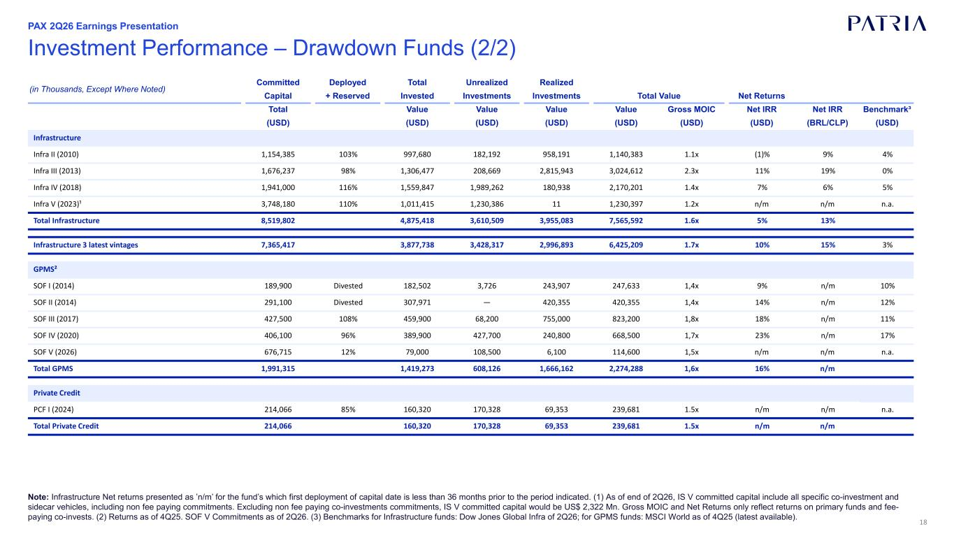
18 Investment Performance – Drawdown Funds (2/2) Note: Infrastructure Net returns presented as ’n/m’ for the fund’s which first deployment of capital date is less than 36 months prior to the period indicated. (1) As of end of 2Q26, IS V committed capital include all specific co-investment and sidecar vehicles, including non fee paying commitments. Excluding non fee paying co-investments commitments, IS V committed capital would be US$ 2,322 Mn. Gross MOIC and Net Returns only reflect returns on primary funds and fee- paying co-invests. (2) Returns as of 4Q25. SOF V Commitments as of 2Q26. (3) Benchmarks for Infrastructure funds: Dow Jones Global Infra of 2Q26; for GPMS funds: MSCI World as of 4Q25 (latest available). (in Thousands, Except Where Noted) Committed Deployed Total Unrealized Realized Capital + Reserved Invested Investments Investments Total Value Net Returns Total Value Value Value Value Gross MOIC Net IRR Net IRR Benchmark³ (USD) (USD) (USD) (USD) (USD) (USD) (USD) (BRL/CLP) (USD) Infrastructure Infra II (2010) 1,154,385 103% 997,680 182,192 958,191 1,140,383 1.1x (1)% 9% 4% Infra III (2013) 1,676,237 98% 1,306,477 208,669 2,815,943 3,024,612 2.3x 11% 19% 0% Infra IV (2018) 1,941,000 116% 1,559,847 1,989,262 180,938 2,170,201 1.4x 7% 6% 5% Infra V (2023)¹ 3,748,180 110% 1,011,415 1,230,386 11 1,230,397 1.2x n/m n/m n.a. Total Infrastructure 8,519,802 4,875,418 3,610,509 3,955,083 7,565,592 1.6x 5% 13% Infrastructure 3 latest vintages 7,365,417 3,877,738 3,428,317 2,996,893 6,425,209 1.7x 10% 15% 3% GPMS² SOF I (2014) 189,900 Divested 182,502 3,726 243,907 247,633 1,4x 9% n/m 10% SOF II (2014) 291,100 Divested 307,971 — 420,355 420,355 1,4x 14% n/m 12% SOF III (2017) 427,500 108% 459,900 68,200 755,000 823,200 1,8x 18% n/m 11% SOF IV (2020) 406,100 96% 389,900 427,700 240,800 668,500 1,7x 23% n/m 17% SOF V (2026) 676,715 12% 79,000 108,500 6,100 114,600 1,5x n/m n/m n.a. Total GPMS 1,991,315 1,419,273 608,126 1,666,162 2,274,288 1,6x 16% n/m Private Credit PCF I (2024) 214,066 85% 160,320 170,328 69,353 239,681 1.5x n/m n/m n.a. Total Private Credit 214,066 160,320 170,328 69,353 239,681 1.5x n/m n/m PAX 2Q26 Earnings Presentation

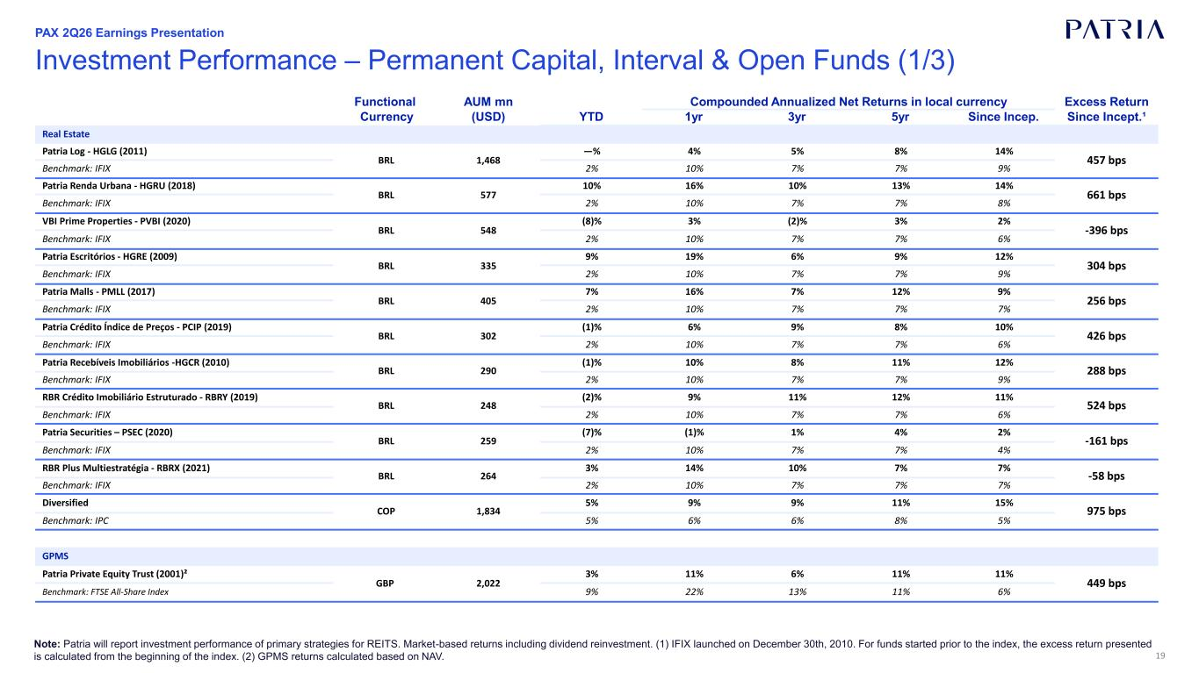
19 Investment Performance – Permanent Capital, Interval & Open Funds (1/3) Note: Patria will report investment performance of primary strategies for REITS. Market-based returns including dividend reinvestment. (1) IFIX launched on December 30th, 2010. For funds started prior to the index, the excess return presented is calculated from the beginning of the index. (2) GPMS returns calculated based on NAV. Functional AUM mn Compounded Annualized Net Returns in local currency Excess Return Currency (USD) YTD 1yr 3yr 5yr Since Incep. Since Incept.¹ Real Estate Patria Log - HGLG (2011) BRL 1,468 —% 4% 5% 8% 14% 457 bps Benchmark: IFIX 2% 10% 7% 7% 9% Patria Renda Urbana - HGRU (2018) BRL 577 10% 16% 10% 13% 14% 661 bps Benchmark: IFIX 2% 10% 7% 7% 8% VBI Prime Properties - PVBI (2020) BRL 548 (8)% 3% (2)% 3% 2% -396 bps Benchmark: IFIX 2% 10% 7% 7% 6% Patria Escritórios - HGRE (2009) BRL 335 9% 19% 6% 9% 12% 304 bps Benchmark: IFIX 2% 10% 7% 7% 9% Patria Malls - PMLL (2017) BRL 405 7% 16% 7% 12% 9% 256 bps Benchmark: IFIX 2% 10% 7% 7% 7% Patria Crédito Índice de Preços - PCIP (2019) BRL 302 (1)% 6% 9% 8% 10% 426 bps Benchmark: IFIX 2% 10% 7% 7% 6% Patria Recebíveis Imobiliários -HGCR (2010) BRL 290 (1)% 10% 8% 11% 12% 288 bps Benchmark: IFIX 2% 10% 7% 7% 9% RBR Crédito Imobiliário Estruturado - RBRY (2019) BRL 248 (2)% 9% 11% 12% 11% 524 bps Benchmark: IFIX 2% 10% 7% 7% 6% Patria Securities – PSEC (2020) BRL 259 (7)% (1)% 1% 4% 2% -161 bps Benchmark: IFIX 2% 10% 7% 7% 4% RBR Plus Multiestratégia - RBRX (2021) BRL 264 3% 14% 10% 7% 7% -58 bps Benchmark: IFIX 2% 10% 7% 7% 7% Diversified COP 1,834 5% 9% 9% 11% 15% 975 bps Benchmark: IPC 5% 6% 6% 8% 5% GPMS Patria Private Equity Trust (2001)² GBP 2,022 3% 11% 6% 11% 11% 449 bps Benchmark: FTSE All-Share Index 9% 22% 13% 11% 6% PAX 2Q26 Earnings Presentation

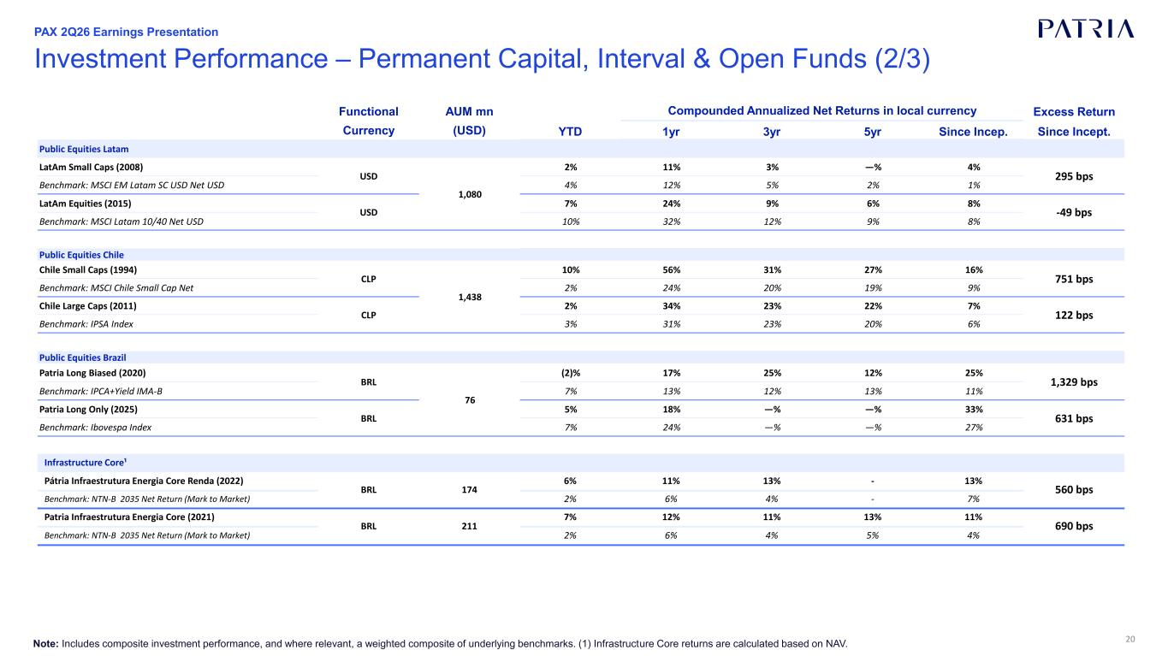
20 Investment Performance – Permanent Capital, Interval & Open Funds (2/3) PAX 2Q26 Earnings Presentation Note: Includes composite investment performance, and where relevant, a weighted composite of underlying benchmarks. (1) Infrastructure Core returns are calculated based on NAV. Functional AUM mn Compounded Annualized Net Returns in local currency Excess Return Currency (USD) YTD 1yr 3yr 5yr Since Incep. Since Incept. Public Equities Latam LatAm Small Caps (2008) USD 1,080 2% 11% 3% —% 4% 295 bps Benchmark: MSCI EM Latam SC USD Net USD 4% 12% 5% 2% 1% LatAm Equities (2015) USD 7% 24% 9% 6% 8% -49 bps Benchmark: MSCI Latam 10/40 Net USD 10% 32% 12% 9% 8% Public Equities Chile Chile Small Caps (1994) CLP 1,438 10% 56% 31% 27% 16% 751 bps Benchmark: MSCI Chile Small Cap Net 2% 24% 20% 19% 9% Chile Large Caps (2011) CLP 2% 34% 23% 22% 7% 122 bps Benchmark: IPSA Index 3% 31% 23% 20% 6% Public Equities Brazil Patria Long Biased (2020) BRL 76 (2)% 17% 25% 12% 25% 1,329 bps Benchmark: IPCA+Yield IMA-B 7% 13% 12% 13% 11% Patria Long Only (2025) BRL 5% 18% —% —% 33% 631 bps Benchmark: Ibovespa Index 7% 24% —% —% 27% Infrastructure Core¹ Pátria Infraestrutura Energia Core Renda (2022) BRL 174 6% 11% 13% - 13% 560 bps Benchmark: NTN-B 2035 Net Return (Mark to Market) 2% 6% 4% - 7% Patria Infraestrutura Energia Core (2021) BRL 211 7% 12% 11% 13% 11% 690 bps Benchmark: NTN-B 2035 Net Return (Mark to Market) 2% 6% 4% 5% 4%

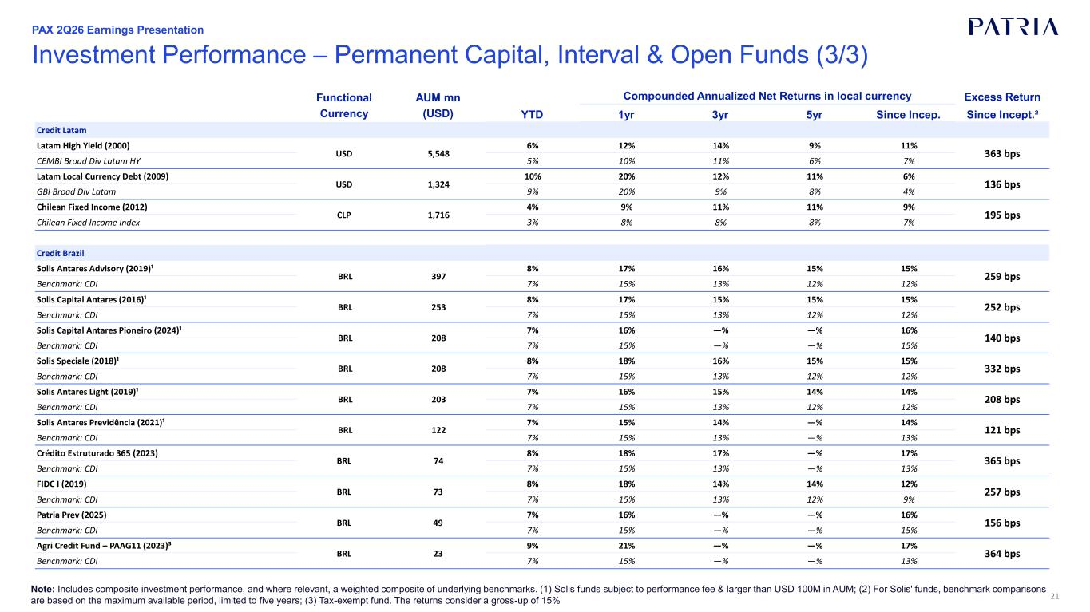
21 Investment Performance – Permanent Capital, Interval & Open Funds (3/3) PAX 2Q26 Earnings Presentation Note: Includes composite investment performance, and where relevant, a weighted composite of underlying benchmarks. (1) Solis funds subject to performance fee & larger than USD 100M in AUM; (2) For Solis' funds, benchmark comparisons are based on the maximum available period, limited to five years; (3) Tax-exempt fund. The returns consider a gross-up of 15% Functional AUM mn Compounded Annualized Net Returns in local currency Excess Return Currency (USD) YTD 1yr 3yr 5yr Since Incep. Since Incept.² Credit Latam Latam High Yield (2000) USD 5,548 6% 12% 14% 9% 11% 363 bps CEMBI Broad Div Latam HY 5% 10% 11% 6% 7% Latam Local Currency Debt (2009) USD 1,324 10% 20% 12% 11% 6% 136 bps GBI Broad Div Latam 9% 20% 9% 8% 4% Chilean Fixed Income (2012) CLP 1,716 4% 9% 11% 11% 9% 195 bps Chilean Fixed Income Index 3% 8% 8% 8% 7% Credit Brazil Solis Antares Advisory (2019)¹ BRL 397 8% 17% 16% 15% 15% 259 bps Benchmark: CDI 7% 15% 13% 12% 12% Solis Capital Antares (2016)¹ BRL 253 8% 17% 15% 15% 15% 252 bps Benchmark: CDI 7% 15% 13% 12% 12% Solis Capital Antares Pioneiro (2024)¹ BRL 208 7% 16% —% —% 16% 140 bps Benchmark: CDI 7% 15% —% —% 15% Solis Speciale (2018)¹ BRL 208 8% 18% 16% 15% 15% 332 bps Benchmark: CDI 7% 15% 13% 12% 12% Solis Antares Light (2019)¹ BRL 203 7% 16% 15% 14% 14% 208 bps Benchmark: CDI 7% 15% 13% 12% 12% Solis Antares Previdência (2021)¹ BRL 122 7% 15% 14% —% 14% 121 bps Benchmark: CDI 7% 15% 13% —% 13% Crédito Estruturado 365 (2023) BRL 74 8% 18% 17% —% 17% 365 bps Benchmark: CDI 7% 15% 13% —% 13% FIDC I (2019) BRL 73 8% 18% 14% 14% 12% 257 bps Benchmark: CDI 7% 15% 13% 12% 9% Patria Prev (2025) BRL 49 7% 16% —% —% 16% 156 bps Benchmark: CDI 7% 15% —% —% 15% Agri Credit Fund – PAAG11 (2023)³ BRL 23 9% 21% —% —% 17% 364 bps Benchmark: CDI 7% 15% —% —% 13%

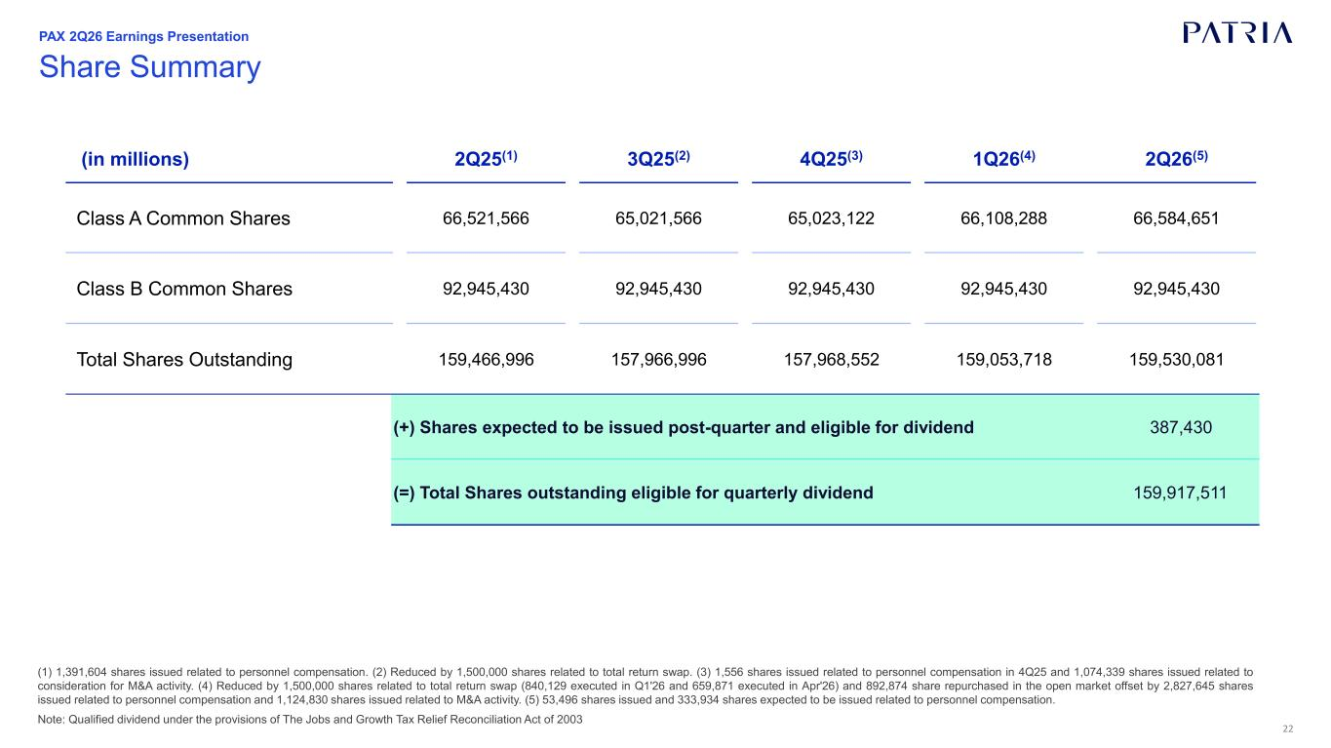
22 (1) 1,391,604 shares issued related to personnel compensation. (2) Reduced by 1,500,000 shares related to total return swap. (3) 1,556 shares issued related to personnel compensation in 4Q25 and 1,074,339 shares issued related to consideration for M&A activity. (4) Reduced by 1,500,000 shares related to total return swap (840,129 executed in Q1'26 and 659,871 executed in Apr'26) and 892,874 share repurchased in the open market offset by 2,827,645 shares issued related to personnel compensation and 1,124,830 shares issued related to M&A activity. (5) 53,496 shares issued and 333,934 shares expected to be issued related to personnel compensation. Note: Qualified dividend under the provisions of The Jobs and Growth Tax Relief Reconciliation Act of 2003 Share Summary PAX 2Q26 Earnings Presentation (in millions) 2Q25(1) 3Q25(2) 4Q25(3) 1Q26(4) 2Q26(5) Class A Common Shares 66,521,566 65,021,566 65,023,122 66,108,288 66,584,651 Class B Common Shares 92,945,430 92,945,430 92,945,430 92,945,430 92,945,430 Total Shares Outstanding 159,466,996 157,966,996 157,968,552 159,053,718 159,530,081 (+) Shares expected to be issued post-quarter and eligible for dividend 387,430 (=) Total Shares outstanding eligible for quarterly dividend 159,917,511


23 Reconciliations & Disclosures PAX 2Q26 Earnings Presentation

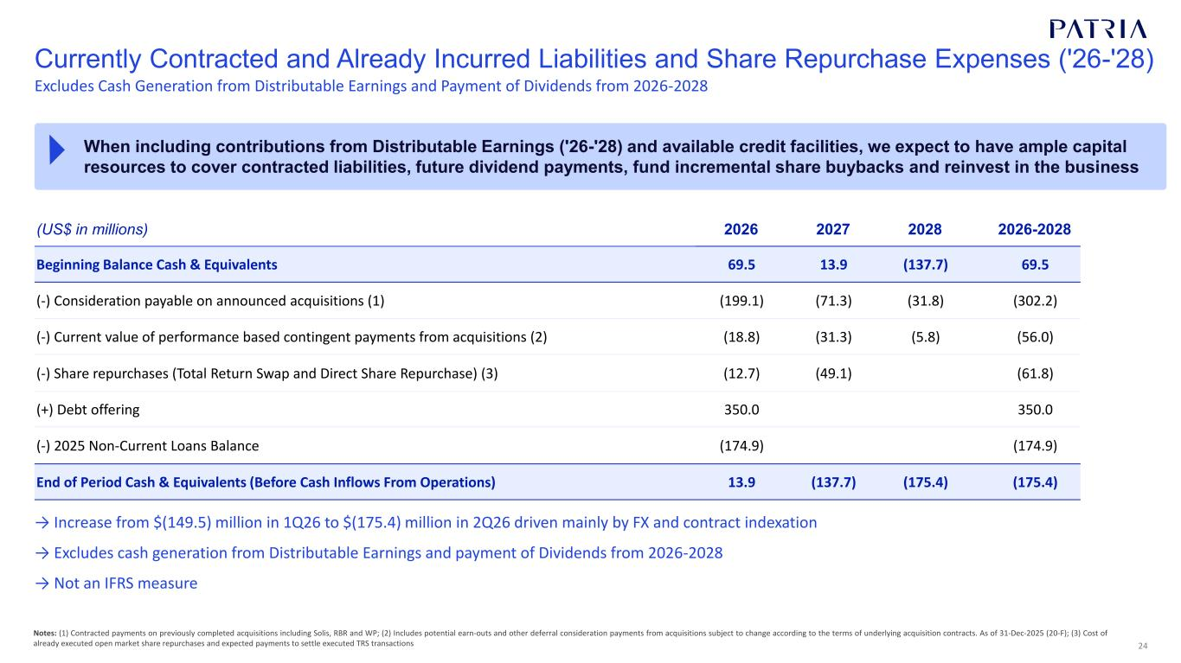
24 Currently Contracted and Already Incurred Liabilities and Share Repurchase Expenses ('26-'28) Notes: (1) Contracted payments on previously completed acquisitions including Solis, RBR and WP; (2) Includes potential earn-outs and other deferral consideration payments from acquisitions subject to change according to the terms of underlying acquisition contracts. As of 31-Dec-2025 (20-F); (3) Cost of already executed open market share repurchases and expected payments to settle executed TRS transactions When including contributions from Distributable Earnings ('26-'28) and available credit facilities, we expect to have ample capital resources to cover contracted liabilities, future dividend payments, fund incremental share buybacks and reinvest in the business (US$ in millions) 2026 2027 2028 2026-2028 Beginning Balance Cash & Equivalents 69.5 13.9 (137.7) 69.5 (-) Consideration payable on announced acquisitions (1) (199.1) (71.3) (31.8) (302.2) (-) Current value of performance based contingent payments from acquisitions (2) (18.8) (31.3) (5.8) (56.0) (-) Share repurchases (Total Return Swap and Direct Share Repurchase) (3) (12.7) (49.1) (61.8) (+) Debt offering 350.0 350.0 (-) 2025 Non-Current Loans Balance (174.9) (174.9) End of Period Cash & Equivalents (Before Cash Inflows From Operations) 13.9 (137.7) (175.4) (175.4) Excludes Cash Generation from Distributable Earnings and Payment of Dividends from 2026-2028 → Increase from $(149.5) million in 1Q26 to $(175.4) million in 2Q26 driven mainly by FX and contract indexation → Excludes cash generation from Distributable Earnings and payment of Dividends from 2026-2028 → Not an IFRS measure

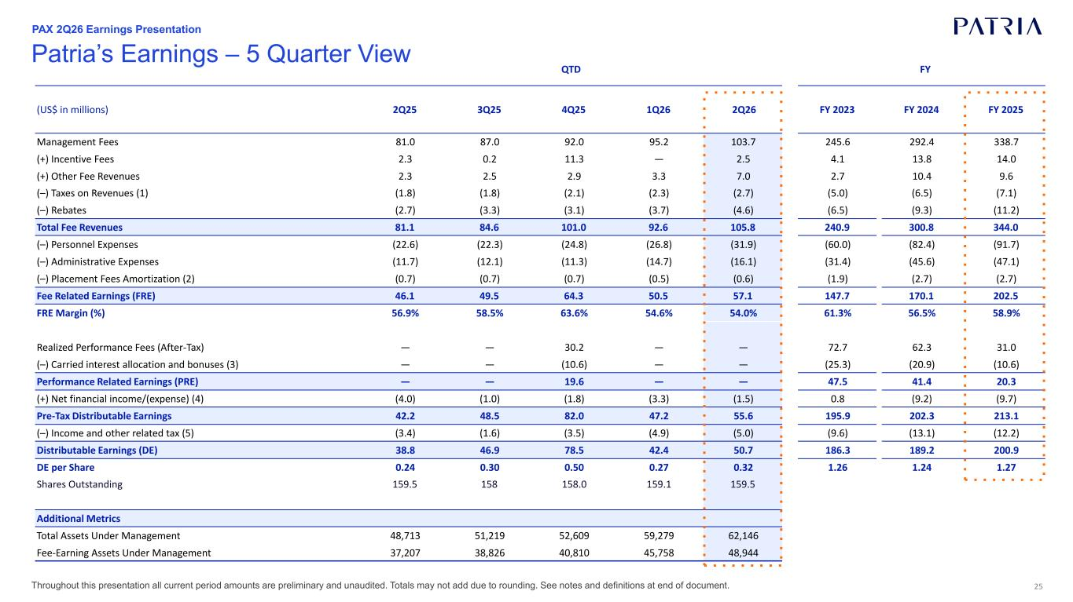
25Throughout this presentation all current period amounts are preliminary and unaudited. Totals may not add due to rounding. See notes and definitions at end of document. Patria’s Earnings – 5 Quarter View (US$ in millions) 2Q25 3Q25 4Q25 1Q26 2Q26 FY 2023 FY 2024 FY 2025 Management Fees 81.0 87.0 92.0 95.2 103.7 245.6 292.4 338.7 (+) Incentive Fees 2.3 0.2 11.3 — 2.5 4.1 13.8 14.0 (+) Other Fee Revenues 2.3 2.5 2.9 3.3 7.0 2.7 10.4 9.6 (–) Taxes on Revenues (1) (1.8) (1.8) (2.1) (2.3) (2.7) (5.0) (6.5) (7.1) (–) Rebates (2.7) (3.3) (3.1) (3.7) (4.6) (6.5) (9.3) (11.2) Total Fee Revenues 81.1 84.6 101.0 92.6 105.8 240.9 300.8 344.0 (–) Personnel Expenses (22.6) (22.3) (24.8) (26.8) (31.9) (60.0) (82.4) (91.7) (–) Administrative Expenses (11.7) (12.1) (11.3) (14.7) (16.1) (31.4) (45.6) (47.1) (–) Placement Fees Amortization (2) (0.7) (0.7) (0.7) (0.5) (0.6) (1.9) (2.7) (2.7) Fee Related Earnings (FRE) 46.1 49.5 64.3 50.5 57.1 147.7 170.1 202.5 FRE Margin (%) 56.9% 58.5% 63.6% 54.6% 54.0% 61.3% 56.5% 58.9% Realized Performance Fees (After-Tax) — — 30.2 — — 72.7 62.3 31.0 (–) Carried interest allocation and bonuses (3) — — (10.6) — — (25.3) (20.9) (10.6) Performance Related Earnings (PRE) — — 19.6 — — 47.5 41.4 20.3 (+) Net financial income/(expense) (4) (4.0) (1.0) (1.8) (3.3) (1.5) 0.8 (9.2) (9.7) Pre-Tax Distributable Earnings 42.2 48.5 82.0 47.2 55.6 195.9 202.3 213.1 (–) Income and other related tax (5) (3.4) (1.6) (3.5) (4.9) (5.0) (9.6) (13.1) (12.2) Distributable Earnings (DE) 38.8 46.9 78.5 42.4 50.7 186.3 189.2 200.9 DE per Share 0.24 0.30 0.50 0.27 0.32 1.26 1.24 1.27 Shares Outstanding 159.5 158 158.0 159.1 159.5 Additional Metrics Total Assets Under Management 48,713 51,219 52,609 59,279 62,146 Fee-Earning Assets Under Management 37,207 38,826 40,810 45,758 48,944 QTD FY PAX 2Q26 Earnings Presentation

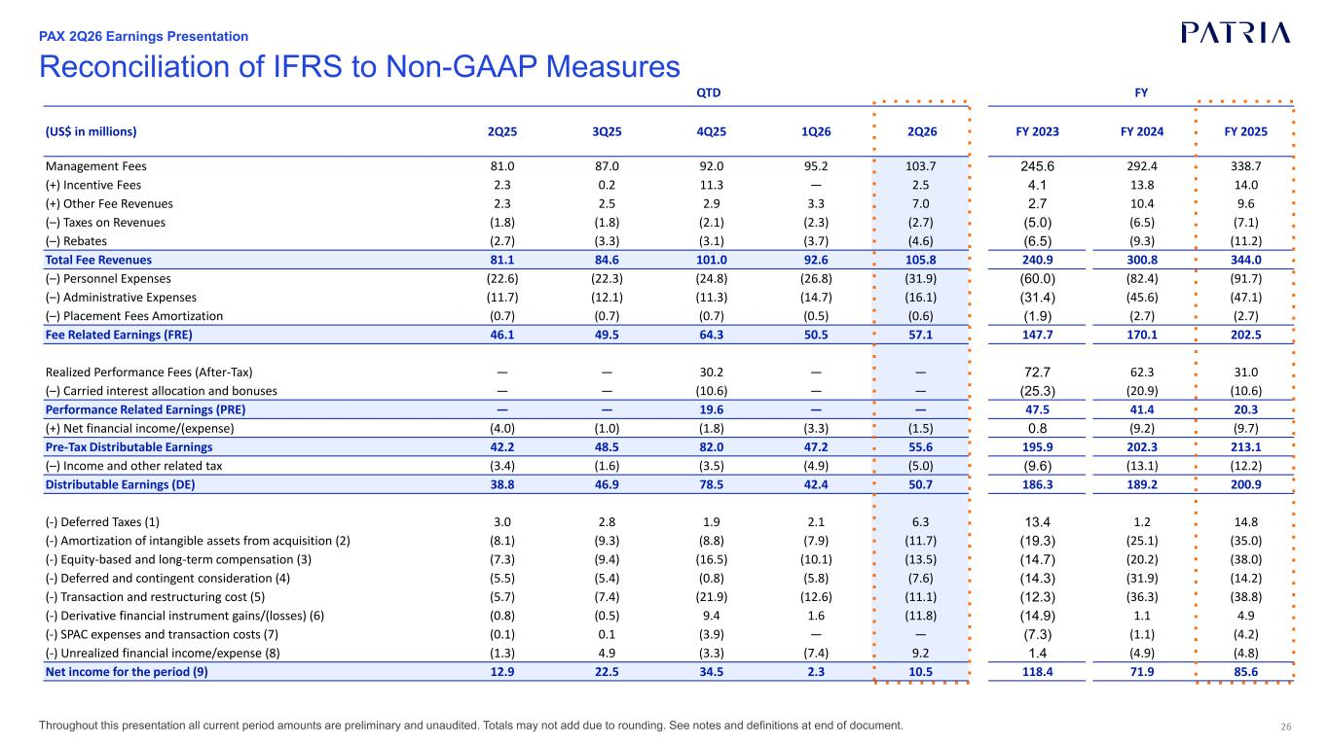
26 Reconciliation of IFRS to Non-GAAP Measures (US$ in millions) 2Q25 3Q25 4Q25 1Q26 2Q26 FY 2023 FY 2024 FY 2025 Management Fees 81.0 87.0 92.0 95.2 103.7 245.6 292.4 338.7 (+) Incentive Fees 2.3 0.2 11.3 — 2.5 4.1 13.8 14.0 (+) Other Fee Revenues 2.3 2.5 2.9 3.3 7.0 2.7 10.4 9.6 (–) Taxes on Revenues (1.8) (1.8) (2.1) (2.3) (2.7) (5.0) (6.5) (7.1) (–) Rebates (2.7) (3.3) (3.1) (3.7) (4.6) (6.5) (9.3) (11.2) Total Fee Revenues 81.1 84.6 101.0 92.6 105.8 240.9 300.8 344.0 (–) Personnel Expenses (22.6) (22.3) (24.8) (26.8) (31.9) (60.0) (82.4) (91.7) (–) Administrative Expenses (11.7) (12.1) (11.3) (14.7) (16.1) (31.4) (45.6) (47.1) (–) Placement Fees Amortization (0.7) (0.7) (0.7) (0.5) (0.6) (1.9) (2.7) (2.7) Fee Related Earnings (FRE) 46.1 49.5 64.3 50.5 57.1 147.7 170.1 202.5 Realized Performance Fees (After-Tax) — — 30.2 — — 72.7 62.3 31.0 (–) Carried interest allocation and bonuses — — (10.6) — — (25.3) (20.9) (10.6) Performance Related Earnings (PRE) — — 19.6 — — 47.5 41.4 20.3 (+) Net financial income/(expense) (4.0) (1.0) (1.8) (3.3) (1.5) 0.8 (9.2) (9.7) Pre-Tax Distributable Earnings 42.2 48.5 82.0 47.2 55.6 195.9 202.3 213.1 (–) Income and other related tax (3.4) (1.6) (3.5) (4.9) (5.0) (9.6) (13.1) (12.2) Distributable Earnings (DE) 38.8 46.9 78.5 42.4 50.7 186.3 189.2 200.9 (-) Deferred Taxes (1) 3.0 2.8 1.9 2.1 6.3 13.4 1.2 14.8 (-) Amortization of intangible assets from acquisition (2) (8.1) (9.3) (8.8) (7.9) (11.7) (19.3) (25.1) (35.0) (-) Equity-based and long-term compensation (3) (7.3) (9.4) (16.5) (10.1) (13.5) (14.7) (20.2) (38.0) (-) Deferred and contingent consideration (4) (5.5) (5.4) (0.8) (5.8) (7.6) (14.3) (31.9) (14.2) (-) Transaction and restructuring cost (5) (5.7) (7.4) (21.9) (12.6) (11.1) (12.3) (36.3) (38.8) (-) Derivative financial instrument gains/(losses) (6) (0.8) (0.5) 9.4 1.6 (11.8) (14.9) 1.1 4.9 (-) SPAC expenses and transaction costs (7) (0.1) 0.1 (3.9) — — (7.3) (1.1) (4.2) (-) Unrealized financial income/expense (8) (1.3) 4.9 (3.3) (7.4) 9.2 1.4 (4.9) (4.8) Net income for the period (9) 12.9 22.5 34.5 2.3 10.5 118.4 71.9 85.6 QTD FY PAX 2Q26 Earnings Presentation Throughout this presentation all current period amounts are preliminary and unaudited. Totals may not add due to rounding. See notes and definitions at end of document.

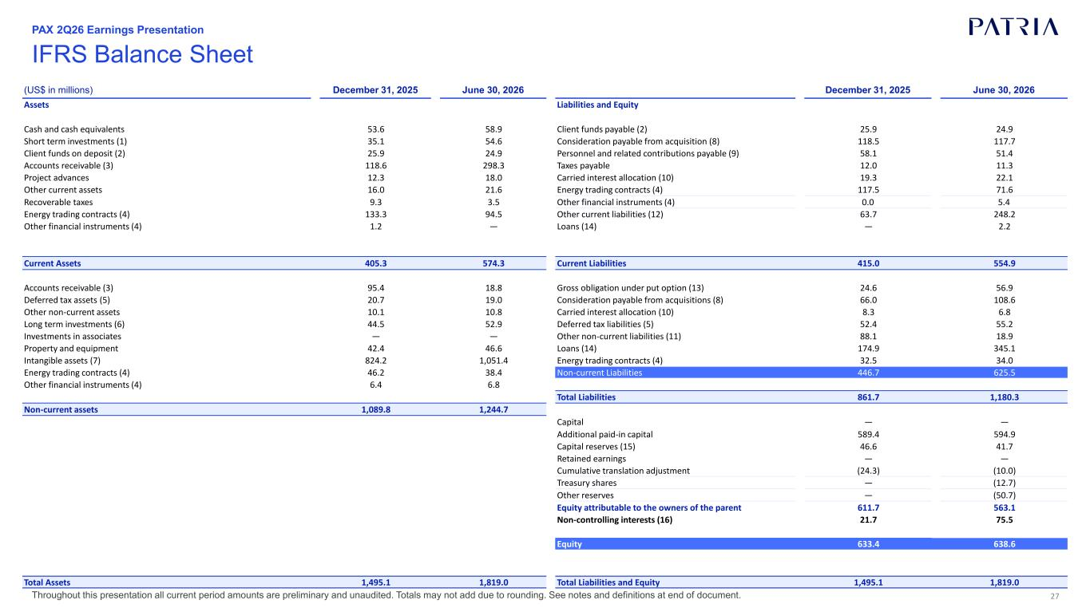
27 IFRS Balance Sheet (US$ in millions) December 31, 2025 June 30, 2026 December 31, 2025 June 30, 2026 Assets Liabilities and Equity Cash and cash equivalents 53.6 58.9 Client funds payable (2) 25.9 24.9 Short term investments (1) 35.1 54.6 Consideration payable from acquisition (8) 118.5 117.7 Client funds on deposit (2) 25.9 24.9 Personnel and related contributions payable (9) 58.1 51.4 Accounts receivable (3) 118.6 298.3 Taxes payable 12.0 11.3 Project advances 12.3 18.0 Carried interest allocation (10) 19.3 22.1 Other current assets 16.0 21.6 Energy trading contracts (4) 117.5 71.6 Recoverable taxes 9.3 3.5 Other financial instruments (4) 0.0 5.4 Energy trading contracts (4) 133.3 94.5 Other current liabilities (12) 63.7 248.2 Other financial instruments (4) 1.2 — Loans (14) — 2.2 Current Assets 405.3 574.3 Current Liabilities 415.0 554.9 Accounts receivable (3) 95.4 18.8 Gross obligation under put option (13) 24.6 56.9 Deferred tax assets (5) 20.7 19.0 Consideration payable from acquisitions (8) 66.0 108.6 Other non-current assets 10.1 10.8 Carried interest allocation (10) 8.3 6.8 Long term investments (6) 44.5 52.9 Deferred tax liabilities (5) 52.4 55.2 Investments in associates — — Other non-current liabilities (11) 88.1 18.9 Property and equipment 42.4 46.6 Loans (14) 174.9 345.1 Intangible assets (7) 824.2 1,051.4 Energy trading contracts (4) 32.5 34.0 Energy trading contracts (4) 46.2 38.4 Non-current Liabilities 446.7 625.5 Other financial instruments (4) 6.4 6.8 Total Liabilities 861.7 1,180.3 Non-current assets 1,089.8 1,244.7 Capital — — Additional paid-in capital 589.4 594.9 Capital reserves (15) 46.6 41.7 Retained earnings — — Cumulative translation adjustment (24.3) (10.0) Treasury shares — (12.7) Other reserves — (50.7) Equity attributable to the owners of the parent 611.7 563.1 Non-controlling interests (16) 21.7 75.5 Equity 633.4 638.6 Total Assets 1,495.1 1,819.0 Total Liabilities and Equity 1,495.1 1,819.0 PAX 2Q26 Earnings Presentation Throughout this presentation all current period amounts are preliminary and unaudited. Totals may not add due to rounding. See notes and definitions at end of document.

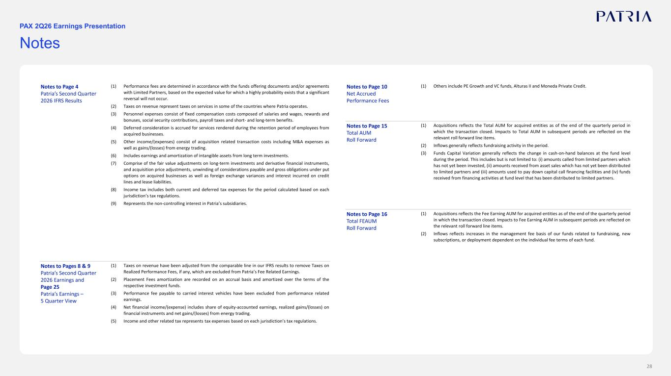
28 Notes PAX 2Q26 Earnings Presentation Notes to Page 4 Patria’s Second Quarter 2026 IFRS Results (1) Performance fees are determined in accordance with the funds offering documents and/or agreements with Limited Partners, based on the expected value for which a highly probability exists that a significant reversal will not occur. (2) Taxes on revenue represent taxes on services in some of the countries where Patria operates. (3) Personnel expenses consist of fixed compensation costs composed of salaries and wages, rewards and bonuses, social security contributions, payroll taxes and short- and long-term benefits. (4) Deferred consideration is accrued for services rendered during the retention period of employees from acquired businesses. (5) Other income/(expenses) consist of acquisition related transaction costs including M&A expenses as well as gains/(losses) from energy trading. (6) Includes earnings and amortization of intangible assets from long term investments. (7) Comprise of the fair value adjustments on long-term investments and derivative financial instruments, and acquisition price adjustments, unwinding of considerations payable and gross obligations under put options on acquired businesses as well as foreign exchange variances and interest incurred on credit lines and lease liabilities. (8) Income tax includes both current and deferred tax expenses for the period calculated based on each jurisdiction’s tax regulations. (9) Represents the non-controlling interest in Patria’s subsidiaries. Notes to Pages 8 & 9 Patria’s Second Quarter 2026 Earnings and Page 25 Patria’s Earnings – 5 Quarter View (1) Taxes on revenue have been adjusted from the comparable line in our IFRS results to remove Taxes on Realized Performance Fees, if any, which are excluded from Patria’s Fee Related Earnings. (2) Placement Fees amortization are recorded on an accrual basis and amortized over the terms of the respective investment funds. (3) Performance fee payable to carried interest vehicles have been excluded from performance related earnings. (4) Net financial income/(expense) includes share of equity-accounted earnings, realized gains/(losses) on financial instruments and net gains/(losses) from energy trading. (5) Income and other related tax represents tax expenses based on each jurisdiction’s tax regulations. Notes to Page 10 Net Accrued Performance Fees (1) Others include PE Growth and VC funds, Alturas II and Moneda Private Credit. Notes to Page 15 Total AUM Roll Forward (1) Acquisitions reflects the Total AUM for acquired entities as of the end of the quarterly period in which the transaction closed. Impacts to Total AUM in subsequent periods are reflected on the relevant roll forward line items. (2) Inflows generally reflects fundraising activity in the period. (3) Funds Capital Variation generally reflects the change in cash-on-hand balances at the fund level during the period. This includes but is not limited to: (i) amounts called from limited partners which has not yet been invested, (ii) amounts received from asset sales which has not yet been distributed to limited partners and (iii) amounts used to pay down capital call financing facilities and (iv) funds received from financing activities at fund level that has been distributed to limited partners. Notes to Page 16 Total FEAUM Roll Forward (1) Acquisitions reflects the Fee Earning AUM for acquired entities as of the end of the quarterly period in which the transaction closed. Impacts to Fee Earning AUM in subsequent periods are reflected on the relevant roll forward line items. (2) Inflows reflects increases in the management fee basis of our funds related to fundraising, new subscriptions, or deployment dependent on the individual fee terms of each fund.

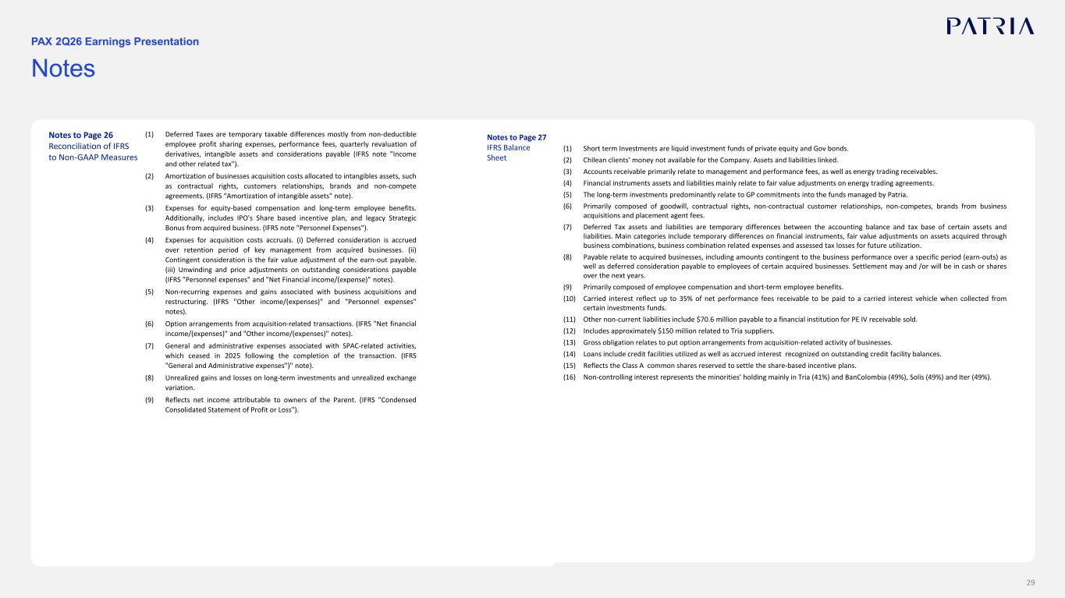
29 Notes PAX 2Q26 Earnings Presentation Notes to Page 26 Reconciliation of IFRS to Non-GAAP Measures (1) Deferred Taxes are temporary taxable differences mostly from non-deductible employee profit sharing expenses, performance fees, quarterly revaluation of derivatives, intangible assets and considerations payable (IFRS note "Income and other related tax"). (2) Amortization of businesses acquisition costs allocated to intangibles assets, such as contractual rights, customers relationships, brands and non-compete agreements. (IFRS “Amortization of intangible assets" note). (3) Expenses for equity-based compensation and long-term employee benefits. Additionally, includes IPO's Share based incentive plan, and legacy Strategic Bonus from acquired business. (IFRS note "Personnel Expenses"). (4) Expenses for acquisition costs accruals. (i) Deferred consideration is accrued over retention period of key management from acquired businesses. (ii) Contingent consideration is the fair value adjustment of the earn-out payable. (iii) Unwinding and price adjustments on outstanding considerations payable (IFRS "Personnel expenses" and "Net Financial income/(expense)" notes). (5) Non-recurring expenses and gains associated with business acquisitions and restructuring. (IFRS "Other income/(expenses)" and "Personnel expenses" notes). (6) Option arrangements from acquisition-related transactions. (IFRS "Net financial income/(expenses)" and "Other income/(expenses)" notes). (7) General and administrative expenses associated with SPAC-related activities, which ceased in 2025 following the completion of the transaction. (IFRS "General and Administrative expenses")" note). (8) Unrealized gains and losses on long-term investments and unrealized exchange variation. (9) Reflects net income attributable to owners of the Parent. (IFRS "Condensed Consolidated Statement of Profit or Loss"). Notes to Page 27 IFRS Balance Sheet (1) Short term Investments are liquid investment funds of private equity and Gov bonds. (2) Chilean clients' money not available for the Company. Assets and liabilities linked. (3) Accounts receivable primarily relate to management and performance fees, as well as energy trading receivables. (4) Financial instruments assets and liabilities mainly relate to fair value adjustments on energy trading agreements. (5) The long-term investments predominantly relate to GP commitments into the funds managed by Patria. (6) Primarily composed of goodwill, contractual rights, non-contractual customer relationships, non-competes, brands from business acquisitions and placement agent fees. (7) Deferred Tax assets and liabilities are temporary differences between the accounting balance and tax base of certain assets and liabilities. Main categories include temporary differences on financial instruments, fair value adjustments on assets acquired through business combinations, business combination related expenses and assessed tax losses for future utilization. (8) Payable relate to acquired businesses, including amounts contingent to the business performance over a specific period (earn-outs) as well as deferred consideration payable to employees of certain acquired businesses. Settlement may and /or will be in cash or shares over the next years. (9) Primarily composed of employee compensation and short-term employee benefits. (10) Carried interest reflect up to 35% of net performance fees receivable to be paid to a carried interest vehicle when collected from certain investments funds. (11) Other non-current liabilities include $70.6 million payable to a financial institution for PE IV receivable sold. (12) Includes approximately $150 million related to Tria suppliers. (13) Gross obligation relates to put option arrangements from acquisition-related activity of businesses. (14) Loans include credit facilities utilized as well as accrued interest recognized on outstanding credit facility balances. (15) Reflects the Class A common shares reserved to settle the share-based incentive plans. (16) Non-controlling interest represents the minorities’ holding mainly in Tria (41%) and BanColombia (49%), Solis (49%) and Iter (49%).

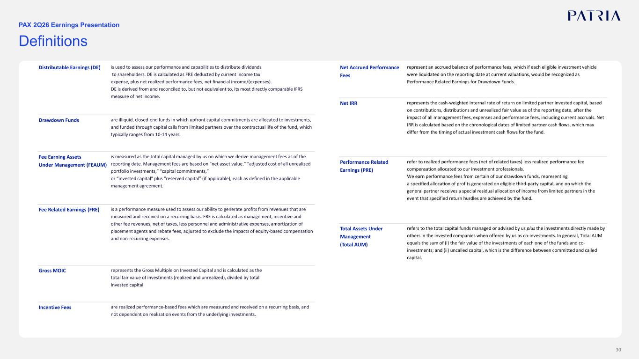
30 Definitions PAX 2Q26 Earnings Presentation Distributable Earnings (DE) is used to assess our performance and capabilities to distribute dividends to shareholders. DE is calculated as FRE deducted by current income tax expense, plus net realized performance fees, net financial income/(expenses). DE is derived from and reconciled to, but not equivalent to, its most directly comparable IFRS measure of net income. Drawdown Funds are illiquid, closed-end funds in which upfront capital commitments are allocated to investments, and funded through capital calls from limited partners over the contractual life of the fund, which typically ranges from 10-14 years. Fee Earning Assets Under Management (FEAUM) is measured as the total capital managed by us on which we derive management fees as of the reporting date. Management fees are based on “net asset value,” “adjusted cost of all unrealized portfolio investments,” “capital commitments,” or “invested capital” plus “reserved capital” (if applicable), each as defined in the applicable management agreement. Fee Related Earnings (FRE) is a performance measure used to assess our ability to generate profits from revenues that are measured and received on a recurring basis. FRE is calculated as management, incentive and other fee revenues, net of taxes, less personnel and administrative expenses, amortization of placement agents and rebate fees, adjusted to exclude the impacts of equity-based compensation and non-recurring expenses. Gross MOIC represents the Gross Multiple on Invested Capital and is calculated as the total fair value of investments (realized and unrealized), divided by total invested capital Incentive Fees are realized performance-based fees which are measured and received on a recurring basis, and not dependent on realization events from the underlying investments. Net Accrued Performance Fees represent an accrued balance of performance fees, which if each eligible investment vehicle were liquidated on the reporting date at current valuations, would be recognized as Performance Related Earnings for Drawdown Funds. Net IRR represents the cash-weighted internal rate of return on limited partner invested capital, based on contributions, distributions and unrealized fair value as of the reporting date, after the impact of all management fees, expenses and performance fees, including current accruals. Net IRR is calculated based on the chronological dates of limited partner cash flows, which may differ from the timing of actual investment cash flows for the fund. Performance Related Earnings (PRE) refer to realized performance fees (net of related taxes) less realized performance fee compensation allocated to our investment professionals. We earn performance fees from certain of our drawdown funds, representing a specified allocation of profits generated on eligible third-party capital, and on which the general partner receives a special residual allocation of income from limited partners in the event that specified return hurdles are achieved by the fund. Total Assets Under Management (Total AUM) refers to the total capital funds managed or advised by us plus the investments directly made by others in the invested companies when offered by us as co-investments. In general, Total AUM equals the sum of (i) the fair value of the investments of each one of the funds and co- investments; and (ii) uncalled capital, which is the difference between committed and called capital.



